Appendix A: Variables from

This appendix contains the variables and indexes that are used throughout the SPSS demonstrations and the end-of-chapter exercises. All of these data are freely available on the Internet, so I could have simply pointed you to them and have you download the original datasets on your own. However, it can be difficult and time-consuming to get these datasets up and running. I have done most of this footwork for you: I have recoded most of the variables and created dozens of indexes. Looking at each dataset in the Variable View in SPSS, you will see the original variables at the top, and all of the recoded variables at the bottom. The name of any variable that I recoded starts with an “XY.” For example, in the 2020 ANES dataset, there is an original variable called AGE: age of the respondent in years. From this variable, I created two XY variables: XYAGE4CAT (age in four categories) and XYAGESQUARED (the square of the age-in-years variable). In the PewKids dataset, there is an original variable called psex: sex of the parent, coded Male = 1, Female = 2. Because dichotomies in regression should be coded 0 and 1, I created a variable called XYpsex, where Male = 0, and Female = 1. I also created reference-group sets, interaction terms,and squared variables. These are all explained in the following pages. The majority of the exercises use these XY variables, though occasionally an exercise will ask you to use a non-recoded variable (i.e., if the original variable “age” was already fine the way it was without recoding). As with any dataset, it is important to recognize that the findings we develop with these datasets are our own, not the responsibility of the creators of the datasets.

Variables from the 2016 American National Election Study
Variables from this dataset are used in the SPSS Demonstrations.

PERSONAL INFORMATION

CASEID: The case identification number of the respondent

MODE: The mode through which data were collected from the respondent. Face-to-face (coded as 1), web (coded as 2).

PREPOST: Did the respondent complete both a pre-election and post-election interview, or just a pre-election interview? Pre-election interview only (coded as 0), pre-election and post-election interview completed (coded as 1).

FAMSIZE: With how many family members is the respondent living?

CHLDHOUSE: How many children aged 0-17 are in the respondent’s household?

HLTHINS: Do you presently have any kind of health insurance? Yes (coded as 1), no (coded as 2).

HEALTH: Would you say that in general your health is: Excellent (coded as 1), very good (coded as 2), good (coded as 3), fair (coded as 4), poor (coded as 5).

TRUST: Generally speaking, how often can you trust other people? Always (coded as 1), most of the time (coded as 2), about half the time (coded as 3), some of the time (coded as 4), never (coded as 5).

AGE: respondent’s age in years.

XYAGE4CAT: a recoded version of the AGE variable, putting age into four categories: 18-34 (coded as 0), 35-50 (coded as 1), 51-63 (coded as 2), 64 & up (coded as 3).

AGEGRP: respondent’s age grouped into thirteen categories.

MARITAL: Are you now married, widowed, divorced, separated or never married? Married (coded as 1), married but spouse absent (coded as 2), widowed (coded as 3), divorced (coded as 4), separated (coded as 5), never married (coded as 6).

XYMARITAL: A collapsed version of the MARITAL variable, where married is coded as 0, widowed as 1, divorced/separated as 2, and never married as 3.

A set of three reference group variables where married is the reference group:
XYMARITALWID: where widowed is coded as 1, not widowed is coded as 0
XYMARITALDIV: where divorced/separated is coded as 1, not divorced/separated is coded as 0
XYMARITALNEV: where never married is coded as 1, not never married is coded as 0

DPSTATUS: respondent’s domestic partnership status (asked if respondent’s marital status is never married, widowed, divorced, or separated): Are you currently living with a partner, or
not? Yes living with a partner (coded as 1), no not living with a partner (coded as 2).

DEGREE: What is the highest level of school you have completed or the highest degree
you have received? Less than 1st grade (coded as 1), 1st, 2nd, 3rd or 4th grade (coded as 2), 5th or 6th grade (coded as 3), 7th or 8th grade (coded as 4), 9th grade (coded as 5), 10th grade (coded as 6), 11th grade (coded as 7), 12th grade no diploma (coded as 8), High school graduate- high school diploma or equivalent (coded as 9), Some college but no degree (coded as 10), Associate degree in college - occupational/vocational program (coded as 11), Associate degree in
college – academic program (coded as 12), Bachelor’s degree (coded as 13), Master’s degree (coded as 14), professional school degree (coded as 15), Doctorate degree (coded as 16), Other specify given as: high school graduate (coded as 90), Other SPECIFY (coded as 95).

XYEDUC: A recoded variable based on the original DEGREE variable, to the closest approximation the number of years of education the respondent has achieved.

SPDEGREE: Spouse/partner’s highest level of education (same categories as the DEGREE variable).

RACE: I am going to read you a list of five race categories. Please choose one or more races that you consider yourself to be: White, non-Hispanic (coded as 1), Black, non-Hispanic (coded as 2), Asian, native Hawaiian or other Pacific Islander, non-Hispanic (coded as 3), Native American or Alaska Native, non-Hispanic (coded as 4), Hispanic (coded as 5), Other non-Hispanic including multiple races (coded as 6).

XYRACE: a recoded version of the RACE variable, with three categories: White (coded as 0), Black (coded as 1), other (coded as 2).

XYRACEWB: a recoded version of the RACE variable, with two categories: White (coded as 0), Black (coded as 1). Other races were coded as missing for this variable.

XYRACEWNW: a recoded version of the RACE variable, with two categories: White (coded as 0), nonwhite (coded as 1).

A set of four reference-group variables, where white is the reference group:
XYRACEBLACK: where Black is coded as 1, not Black is coded as 0
XYRACEASIAN: where Asian is coded as 1, not Asian is coded as 0
XYRACENATAM: where Native American is coded as 1, not Native American is coded as 0
XYRACEHISP: where Hispanic is coded as 1, not Hispanic is coded as 0

BORN: In what state, country, or territory were you born? A U.S. state or D.C. (coded as 1), Puerto Rico (coded as 2), another U.S. territory (coded as 3), another country (coded as 4).

XYBORN: a recoded version of the BORN variable, where born in U.S. is coded as 0, and born outside U.S. is coded as 1.

PARBORN: Where were your parents born? Both parents born in the U.S. (coded as 1), one parent born in the U.S. (coded as 2), both parents born in another country (coded as 3).

A set of two reference group variables, where the reference group is both parents born in U.S.:
XYPARBORN1OUT: where one parent born in the U.S. is coded as 1, otherwise 0
XYPARBORN2OUT: where both parents born in another country is coded as 1, otherwise 0

GRANBORN: How many of your grandparents, if any, were born outside the U.S.A.?

INTRHOME: Do you or does anyone in this household connect to the Internet from home? Yes (coded as 1), no (coded as 2).

CELLLAND: What type of telephone numbers can be used to reach your household? Only landline service (coded as 1), only cell service (coded as 2), both landline and cell service (coded as 3).

CELLPHONE: Do you personally have a cell phone, or not? Yes, have a cell phone (coded as 1), no, do not have a cell phone (coded as 2).

SMARTPHONE: Do you have a ‘smartphone’ or not? By ‘smartphone,’ we mean a cell phone that will run apps and connect to the Internet, like an iPhone or Android phone. Yes, have a smartphone (coded as 1), no smartphone (coded as 2).
HOMEOWN: Home ownership: Pay rent (coded as 1), pay mortgage (coded as 2), own home with no payments due (coded as 3), some other arrangement (coded as 4).

GENDER: What is your gender? Male (coded as 1), female (coded as 2), other (coded as 3). Since there were only eleven people who identified as other, these eleven respondents’ gender was coded as missing in order to allow for easier analyses.

XYGENDER: a recoded version of the GENDER variable, where male is coded as 0 and female is coded as 1.

STOCKS: Do you personally, or jointly with a spouse, have any money invested in the stock market right now – either in an individual stock or in a mutual fund? Yes (coded as 1), no (coded as 2).

INCOMEPRE: respondent’s income: Under $5,000 (coded as 1), $5,000-$9,999 (coded as 2), $10,000-$12,499 (coded as 3), $12,500-$14,999 (coded as 4), $15,000-$17,499 (coded as 5), $17,500-$19,999 (coded as 6), $20,000-$22,499 (coded as 7), $22,500-$24,999 (coded as 8), $25,000-$27,499 (coded as 9), $27,500-$29,999 (coded as 10), $30,000-$34,999 (coded as 11), $35,000-$39.999 (coded as 12), $40,000-$44,999 (coded as 13), $45,000-$49,999 (coded as 14), $50,000-$54,999 (coded as 15), $55,000-$59,999 (coded as 16), $60,000-$64,999 (coded as 17), $65,000-$69,999 (coded as 18), $70,000-$74,999 (coded as 19), $75,000-$79,999 (coded as 20), $80,000-$89,999 (coded as 21), $90,000-$99,999 (coded as 22), $100,000-$109,999 (coded as 23), $110,000-$124,999 (coded as 24), $125,000-$149,999 (coded as 25), $150,000-$174,999 (coded as 26), $175,000-$249,999 (coded as 27), $250,000 or more (coded as 28).

XYINCOME: a recoded version of INCOMEPRE, coded as respondent’s income in $1,000s.

SEXORNTSELF: Do you consider yourself to be heterosexual or straight, homosexual or gay or lesbian, or bisexual? Heterosexual or straight (coded as 1), homosexual or gay or lesbian (coded as 2), bisexual (coded as 3).

XYSEXORNTSELF: Recoded version of SEXORNTSELF, where heterosexual is coded as 0, and gay, lesbian, or bisexual is coded as 1.

SEXORNTOTH: Among your immediate family members, relatives, neighbors, co-workers, or close friends, are any of them gay, lesbian, or bisexual as far as you know? Yes (coded as 1), no (coded as 2).

XYSEXORNTOTH: Recoded version of SEXORNTOTH, where No family or friends gay, lesbian, or bisexual coded as 0, and Yes family or friends gay, lesbian, or bisexual coded as 1.

LIFESAT: All things considered, how satisfied are you with your life as a whole these
days? Extremely satisfied (coded as 1), very satisfied (coded as 2), moderately satisfied (coded as 3), slightly satisfied (coded as 4), not satisfied as all (coded as 5).

CLASS1: How would you describe your social class? Lower class (coded as 1), working class (coded as 2), middle class (coded as 3), upper class (coded as 4).

CLASS2 (asked if the respondent said they were middle class): Lower middle class (coded as 1), middle class (coded as 2), upper middle class (coded as 3).

XYCLASS: Recoded version of CLASS1 and CLASS2, combining them into a single variable where lower class is coded as 0, working class is coded as 1, lower middle class is coded as 2, middle class is coded as 3, upper middle class is coded as 4, and upper class is coded as 5.

POLICESTOP: During the past 12 months, were you or any of your family members stopped or questioned by a police officer, or did this not happen in the past 12 months? Was stopped or questioned in the past 12 months (coded as 1), was not stopped or questioned in the past 12 months (coded as 2).

ARRESTED: Have you ever been arrested, or has that never happened to you? Have been arrested (coded as 1), never arrested (coded as 2).

XYARRESTED: Recoded version of the ARRESTED variable, where has never been arrested is coded as 0, and has been arrested is coded as 1.

GUNSNUM: How many guns do you or anyone else living here own?

XYGUNSNUM: Recoded version of GUNSNUM, where does not own gun is coded as 0, and owns one or more guns is coded as 1.

RELIGION

RELIMP: Do you consider religion to be an important part of your life, or not? Important (coded as 1), unimportant (coded as 2).

RELGUIDE: Would you say your religion provides some guidance in your day-to-day living, quite a bit of guidance, or a great deal of guidance? Some (coded as 1), quite a bit (coded as 2), a great deal (coded as 3).

XYRELIMP: Combines RELIMP and RELGUIDE to create a variable where religion is unimportant is coded as 0, religion provides some guidance is coded as 1, religion provides quite a bit of guidance is coded as 2, and religion provides a great deal of guidance is coded as 3.

BIBLE: Which of these statements comes closest to describing your feelings about the Bible?
The Bible is the actual word of God and is to be taken literally, word for word (coded as 1), the Bible is the word of God but not everything in it should be taken literally (coded as 2), the Bible is a book written by men and is not the word of God (coded as 3).

XYBIBLE: Recoded version of the BIBLE variable, where not a biblical literalist is coded as 0, and is a biblical literalist is coded as 1.

ATTENDEV: Lots of things come up that keep people from attending religious services even if they want to. Thinking about your life these days, do you ever attend religious services, apart from occasional weddings, baptisms or funerals? Yes (coded as 1), no (coded as 2).

ATTENDOFT: If answered yes to ATTENDEV: Do you go to religious services every week, almost every week, once or twice a month, a few times a year, or never? Every week (coded as 1), almost every week (coded as 2), once or twice a month (coded as 3), a few times a year (coded as 4), never (coded as 5).

ATTENDLOT: If answered every week to ATTENDOFT: Would you say you go to religious services once a week or more often than once a week? Once a week (coded as 1), more than once a week (coded as 2).

XYATTEND: Combines ATTENDEV, ATTENDOFT, and ATTENDLOT to create a variable that is the number of times the respondent attends religious services per month.

RELIG: Major group religion summary. Mainline Protestant (coded as 1), Evangelical Protestant (coded as 2), Black Protestant (coded as 3), Catholic (coded as 4), Undifferentiated Christian (coded as 5), Jewish (coded as 6), other religion (coded as 7), not religious (coded as 8).

XYRELIG: A recoded version of the RELIG variable, keeping only five groups, making other groups missing: Mainline Protestant (coded as 0), Evangelical Protestant (coded as 1), Catholic (coded as 2), Jewish (coded as 3), not religious (coded as 4).

A set of four reference-group variables based on the XYRELIG variable. Those who are not religious are the reference group.
XYRELIGMLPROT, where Mainline Protestant is coded as 1, otherwise coded as 0
XYRELIGEVPROT: where Evangelical Protestant is coded as 1, otherwise coded as 0
XYRELIGCATH: where Catholic is coded as 1, otherwise coded as 0
XYRELIGJEW: where Jewish is coded as 1, otherwise coded as 0

POLITICAL ENGAGEMENT

POLATTNPRE: How often do you pay attention to what’s going on in government and politics?
Always (coded as 1), most of the time (coded as 2), about half the time (coded as 3), some of the time (coded as 4), or never (coded as 5).

POLINTPRE: Some people don’t pay much attention to political campaigns. How about you? Would you say that you have been…very much interested (coded as 1), somewhat interested (coded as 2) or not much interested (coded as 3).

NEWSWK: During a typical week, how many days do you watch, read, or listen to news on TV, radio, printed newspapers, or the Internet, not including sports?

NEWSATTN: If respondents answered more than 0 for the variable NEWSWK, they were then asked: How much attention do you pay to news about national politics on TV, radio, printed newspapers, or the Internet? A great deal (coded as 1), a lot (coded as 2), a moderate amount (coded as 3), a little (coded as 4), or none at all (coded as 5).

MEDIASOC: During a typical week, how many days do you use social media such as Twitter or Facebook?

PROTEST: During the past 12 months, have you joined in a protest march, rally, or demonstration, or have you not done this in the past 12 months? Have done this (coded as 1), have not done this (coded as 2).

XYPROTEST: a recoded version of the PROTEST variable, with Yes coded as 1 and No coded as 0.

PETITION: During the past 12 months, have you signed a petition on the Internet or on paper about a political or social issue, or have you not done this in the past 12 months? Have done this (coded as 1), have not done this (coded as 2).

GIVRELIG: During the past 12 months, have you ever given money to a religious organization,
or have you not done this in the past 12 months? Have done this (coded as 1), have not done this (coded as 2).

GIVSOCPOL: Not counting a religious organization, during the past 12 months, have you given money to any other organization concerned with a political or social issue, or have you not done this in the past 12 months? Have done this (coded as 1), have not done this (coded as 2).

VOTE16POST: How about the election for President? Did you vote for a candidate for President? Yes (coded as 1), No (coded as 2).

VOTE16WHOPOST: Who did you vote for? Hillary Clinton (coded as 1), Donald Trump (coded as 2), Gary Johnson (coded as 3), Jill Stein (coded as 4), or someone else (coded as 5)

XYVOTEWHO: A recoded version of VOTE16WHOPOST, with voted for Donald Trump coded as 0 and voted for Hillary Clinton coded as 1.

BOYCOTT: In the past 12 months, how often have you either bought or declined to buy a certain product or service because of the social or political values of the company that provides it? Never (coded as 1), once in a while (coded as 2), about half the time (coded as 3), most of the time (coded as 4), or all the time (coded as 5).

POLDISC: Do you ever discuss politics with your family or friends? Yes (coded as 1), No (coded as 2).

POLDISCDAYS (asked if they answered Yes to POLDISC variable): How many days in the past week did you talk about politics with family or friends?

NUMORG: How many organizations are you currently a member of?

DOCOMM: During the past 12 months, have you worked with other people to deal with some issue facing your community? Have done this (coded as 1), have not done this (coded as 2).

DOMTG: During the past 12 months, did you attend a meeting about an issue facing your local community or schools? Have done this (coded as 1), have not done this (coded as 2).

DOVOL: Many people say they have less time these days to do volunteer work. What about you, were you able to devote any time to volunteer work in the past 12 months or did you not do so? Have done this (coded as 1), have not done this (coded as 2).

XYDOVOL: A recoded version of DOVOL, with Yes coded as 1 and No coded as 0.

VARIOUS ATTITUDES

POLVIEWSPRE: (pre-election survey) Where would you place yourself on this scale, or haven’t you thought much about this? Extremely liberal (coded 1), liberal (coded 2), slightly liberal (coded 3), moderate (coded 4), slightly conservative (coded 5), conservative (coded 6), extremely conservative (coded 7).

POLVIEWSPOST: (post-election survey) Where would you place yourself on this scale, or haven’t you thought much about this? Extremely liberal (coded 1), liberal (coded 2), slightly liberal (coded 3), moderate (coded 4), slightly conservative (coded 5), conservative (coded 6), extremely conservative (coded 7).

XYPOLVIEWSPRE: recoded version of POLVIEWSPRE, where extremely liberal is coded as 0, liberal as 1, etc.

XYPOLVIEWSPOST: recoded version of POLVIEWSPOST, where extremely liberal is coded as 0, liberal as 1, etc.

PARTYID: Generally speaking, do you usually think of yourself as… strong Democrat (coded as 1), not very strong Democrat (coded as 2), Independent Democrat (coded as 3), Independent (coded as 4), Independent Republican (coded as 5), not very strong Republican (coded as 6), strong Republican (coded as 7).

XYPARTYID: recoded version of PARTYID, where strong Democrat is coded as 0, not very strong Democrat as 1, etc.

USWORLD: Turning to some other types of issues facing the country. During the past year, would you say that the United States’ position in the world has grown weaker, stayed about the same, or has it grown stronger? Weaker (coded as 1), stayed the same (coded as 2), stronger (coded as 3).

ISOLATE: Do you agree or disagree with this statement: This country would be better off if we just stayed home and did not concern ourselves with problems in other parts of the world. Agree (coded as 1), disagree (coded as 2).

ENGLIMP: How important do you think it is that everyone in the United States learn to speak English? Very important (coded as 1), somewhat important (coded as 2), not very important (coded as 3), not at all important (coded as 4).

ALLOWREF: Do you favor, oppose, or neither favor nor oppose allowing Syrian refugees to come to the United States? Favor a great deal (coded as 1), favor a moderate amount (coded as 2), favor a little (coded as 3), neither favor nor oppose (coded as 4), oppose a little (coded as 5), oppose a moderate amount (coded as 6), oppose a great deal (coded as 7).

INCGAP: Do you think the difference in incomes between rich people and poor people in the United States today is larger, smaller, or about the same as it was 20 years ago? Much larger (coded as 1), somewhat larger (coded as 2), about the same (coded as 3), somewhat smaller (coded as 4), much smaller (coded as 5).

INEQUAL: do you favor, oppose, or neither favor nor oppose the government trying to reduce the difference in incomes between the richest and poorest households? Favor (coded as 1), oppose (coded as 2), neither favor nor oppose (coded as 3).

EQUALPAY: Do you favor, oppose, or neither favor nor oppose requiring employers to pay women and men the same amount for the same work? Favor a great deal (coded as 1), favor a moderate amount (coded as 2), favor a little (coded as 3), neither favor nor oppose (coded as 4), oppose a little (coded as 5), oppose a moderate amount (coded as 6), oppose a great deal (coded as 7).

GUNBUY: Do you think the federal government should make it more difficult for people to buy a gun than it is now, make it easier for people to buy a gun, or keep these rules about the same as they are now? More difficult (coded as 1), easier (coded as 2), keep these rules about the same (coded as 3).

XYGUNBUY: a recoded version of the GUNBUY variable where make buying gun easier or stay the same is coded as 0, and make buying gun harder is coded as 1.

GUNIMP: How important is this issue (gun access) to you personally? Extremely important (coded as 1), very important (coded as 2), somewhat important (coded as 3), not too important (coded as 4), not important at all (coded as 5).

FRACKING: Fracking is a way to drill for natural gas by pumping high pressure fluid into the ground. Do you favor, oppose, or neither favor nor oppose fracking in the U.S.? Favor (coded as 1), oppose (coded as 2), neither favor nor oppose (coded as 3).

SSSERVE: Do you think business owners who provide wedding-related services should be allowed to refuse services to same-sex couples if same-sex marriage violates their religious beliefs, or do you think business owners should be required to provide services regardless of a couple’s sexual orientation? Feels very strongly should be allowed to refuse (coded as 1), feel moderately strongly should be allowed to refuse (coded as 2), feel a little strongly should be allowed to refuse (coded as 3), feel a little strongly should be required to provide services (coded as 4), feel moderately strongly should be required to provide services (coded as 5), feel very strongly should be required to provide services (coded as 6).

TRANSGEN: Should transgender people – that is, people who identify themselves as the sex or gender different from the one they were born as – have to use the bathrooms of the gender they were born as, or should they be allowed to use the bathrooms of their identified gender? Feel very strongly bathroom of the gender born with (coded as 1), feel moderately strongly bathroom of the gender born with (coded as 2), feel a little strongly bathroom of the gender born with (coded as 3), feel a little strongly bathroom of identified gender (coded as 4), feel a little strongly bathroom of identified gender (coded as 5), feel very strongly bathroom of identified gender (coded as 6).

ABORTION: There has been some discussion about abortion during recent years. Which one of the opinions on this page best agrees with your view? By law, abortion should never be permitted (coded as 1), by law, only in case of rape, incest, or woman’s life in danger (coded as 2), by law, for reasons other than rape, incest, or woman’s life in danger if need established (coded as 3), by law, abortion as a matter of personal choice (coded as 4).

DEATHPEN: Do you favor or oppose the death penalty for persons convicted of murder? Favor strongly (coded as 1), favor not strongly (coded as 2), oppose not strongly (coded as 3), oppose strongly (coded as 4).

PROTESTHIT: When protestors get ‘roughed up’ for disrupting political events, how much
do they generally deserve what happens to them? Not at all (coded as 1), a little (coded as 2), a moderate amount (coded as 3), a lot (coded as 4), a great deal (coded as 5).

SENSITIVE: Some people think that the way people talk needs to change with the times to be more sensitive to people from different backgrounds. Others think that this has already gone too far and many people are just too easily offended. Which is closer to your opinion?
The way people talk needs to change a lot (coded as 1), the way people talk needs to change a little (coded as 2), people are a little too easily offended (coded as 3), people are much too easily offended (coded as 4).

STRLEAD1: What our country really needs is a strong, determined leader who will crush evil and take us back to our true path. Agree strongly (coded as 1), agree somewhat (coded as 2), neither agree nor disagree (coded as 3), disagree somewhat (coded as 4), disagree strongly (coded as 5).

STRLEAD2: Having a strong leader in government is good for the United States even if the leader bends the rules to get things done. Agree strongly (coded as 1), agree somewhat (coded as 2), neither agree nor disagree (coded as 3), disagree somewhat (coded as 4), disagree strongly (coded as 5).

GRASS: Do you favor, oppose, or neither favor nor oppose the use of marijuana being legal? Favor (coded as 1), oppose (coded as 2), neither favor nor oppose (coded as 3).

FEELING THERMOMETERS

Before being asked these questions, the respondents received this explanation: Ratings between 50 degrees and 100 degrees mean that you feel favorable and warm toward the group. Ratings between 0 degrees and 50 degrees mean that you don’t feel favorable toward the group and that you don’t care too much for that group. You would rate the group at the 50-degree mark if you don’t feel particularly warm or cold toward the group.

FTCLINTONPRE: Hillary Clinton (pre-election survey)
FTCLINTONP: Hillary Clinton (post-election survey)
FTTRUMPPRE: Donald Trump (pre-election survey)
FTTRUMPP: Donald Trump (post-election survey)
FTDEMS: Democrats
FTREPUBS: Republicans
FTFUND: Christian Fundamentalists
FTFEMINIST: Feminists
FTLIB: Liberals
FTCONS: Conservatives
FTLABOR: Labor unions
FTPOOR: Poor people
FTBIGBIZ: Big business
FTCOURT: The U.S. Supreme Court
FTGAYS: Gay men and lesbians
FTMUSLIM: Muslims
FTPOLICE: Police
FTTRANS: Transgender people
FTSCI: Scientists
FTBLM: Black Lives Matter
FTASIANS: Asians
FTHISP: Hispanics
FTBLACKS: Blacks
FTILLIMM: Illegal immigrants
FTWHITES: Whites

INDEXES

Affirmative Action Index (XYAFACINDEX):
Two questions:
1.) Are you for or against preferential hiring and promotion of blacks?
Strongly for preferential hiring (coded as 6), not strongly for preferential hiring (coded as 4), not strongly against preferential hiring (coded as 2), strongly against preferential hiring (coded as 0)
2.) Do you favor, oppose, or neither favor nor oppose allowing universities to increase the number of black students studying at their schools by considering race along with other factors when choosing students? Favor a great deal (coded as 6), favor a moderate amount (coded as 5), favor a little (coded as 4), neither favor nor oppose (coded as 3), oppose a little (coded as 2), oppose a moderate amount (coded as 1), oppose a great deal (coded as 0).

Combining these variables results in an index ranging from 0 = no support, up to 12 = full support.

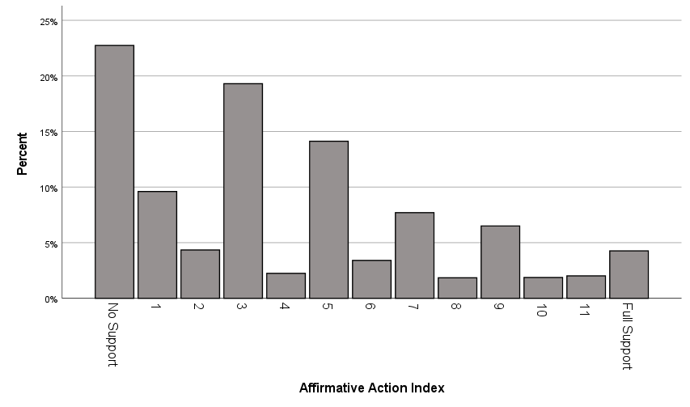

Black Attitudes Index (XYBLKATTINDEX):
Four statements, to which respondents were asked to choose from: agree strongly, agree somewhat, neither agree nor disagree, disagree somewhat, disagree strongly.
1.) Irish, Italians, Jewish and many other minorities overcame prejudice and worked their way up. Blacks should do the same without any special favors. (agree strongly = 0)
2.) Generations of slavery and discrimination have created conditions that make it difficult for
blacks to work their way out of the lower class. (agree strongly = 4)
3.) Over the past few years, blacks have gotten less than they deserve. (agree strongly = 4)
4.) It’s really a matter of some people not trying hard enough, if blacks would only try harder they could be just as well off as whites. (agree strongly = 0)

The resulting index ranges from 0 = no support for Blacks, up to 16 = full support for Blacks.

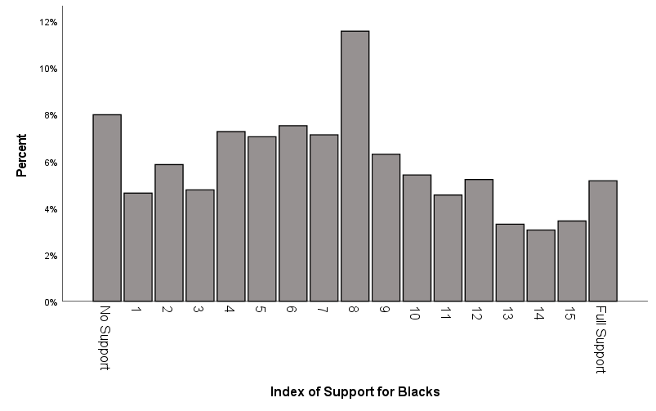

Blacks Negative Stereotypes Index (XYSTWHBLINDEX):
Set of four questions, asking the respondents to rate groups on one 0-to-6-point scale from violent to peaceful, and another 0-to-6-point scale from lazy to hardworking. Combining responses about Blacks and whites, the resulting index ranges from negative 12 =
very negative views of Blacks and very positive views of whites, up to positive 12 = very negative views of whites and very positive views of Blacks.
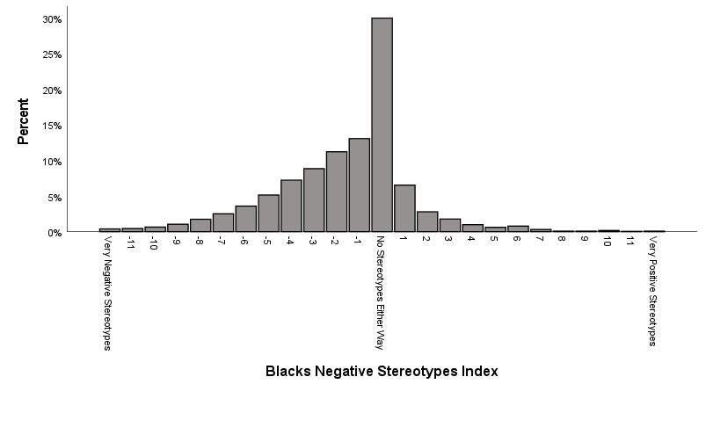
Child Raising Traditionalism Index (XYCHLDTRINDEX):
Four questions, each starting with:
Please tell me which one you think is more important for a child to have:
1.) independence (coded as 0) or respect for elders (coded as 2)
2.) curiosity (coded as 0) or good manners (coded as 2)
3.) obedience (coded as 2) or self-reliance (coded as 0)
4.) being considerate (coded as 0) or well behaved (coded as 2)
Those who volunteered “both” were coded as 1.

Combining these results in an index that goes from 0 = progressive, up to 8 = traditional.

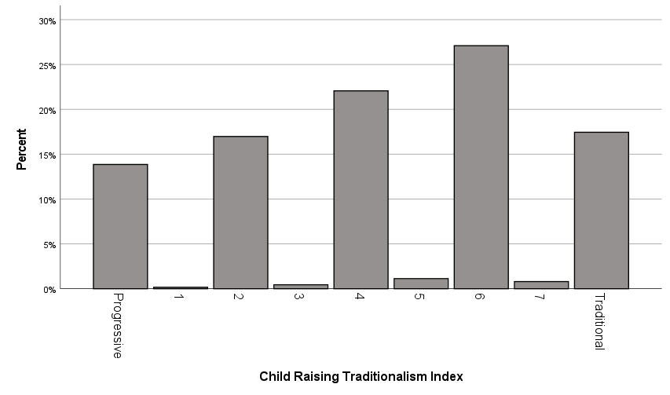

Conspiracy Index (XYCONSPIRINDEX):
Two questions:
1.) Is Barack Obama a Muslim, or is he not a Muslim? possible responses: extremely sure Obama is a Muslim (coded as 9), very sure Obama is a Muslim (coded as 8), moderately sure Obama is a Muslim (coded as 7), a little sure Obama is a Muslim (coded as 6), not sure at all Obama is a Muslim (coded as 5), not sure at all Obama not a Muslim (coded as 4), a little sure Obama not a Muslim (coded as 3), moderately sure Obama not a Muslim (coded as 2), very sure Obama not a Muslim (coded as 1), extremely sure Obama not a Muslim (coded as 0)
2.) Did senior federal government officials know about the terrorist attacks on September 11, 2001 before they happened? possible responses: definitely knew (coded as 9), probably knew (coded as 6), probably did not know (coded as 3), definitely did not know (coded as 0)

Combining these two variables results in an index ranging from 0 = does not believe conspiracies, up to 18 = does believe conspiracies.

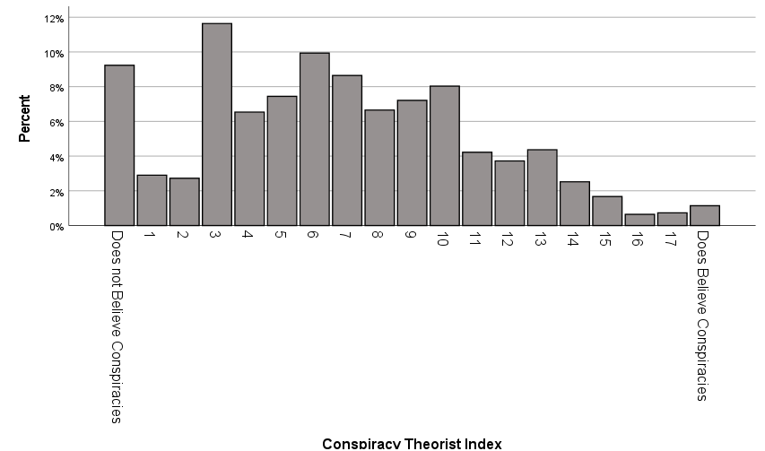

Economic Optimism Index (XYECONINDEX):
Four questions that each had these response categories:
much better (coded as 4), somewhat better (coded as 3), about the same coded as 2), somewhat worse (coded as 1), much worse (coded as 0)
Would you say that compared to 2008, the nation’s economy is now…
What about the next 12 months? Do you expect the economy, in the country as a whole, to get…
Now thinking about the economy in the country as a whole, would you say that over the past year the nation’s economy has gotten…
Would you say that over the past twelve months, the state of the economy in the United States has gotten…

Putting these variables together results in an index ranging from 0 = completely pessimistic about economy, up to 16 = completely optimistic about economy.

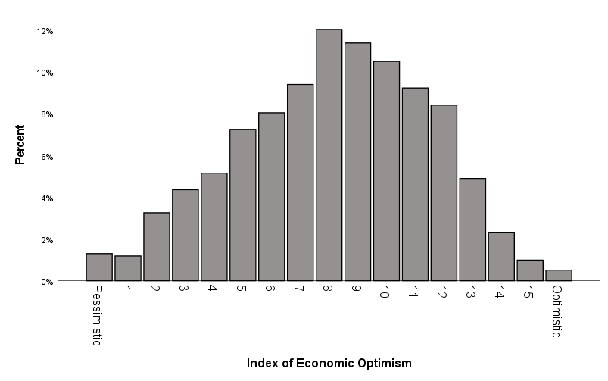

Equality Concern Index (XYEQUALINDEX):
Five statements, each with these response options: agree strongly, agree somewhat, neither agree nor disagree, disagree somewhat, disagree strongly.
1.) Our society should do whatever is necessary to make sure that everyone has an equal opportunity to succeed. (agree strongly coded as 4)
2.) This country would be better off if we worried less about how equal people are. (disagree strongly. (disagree strongly coded as 4)
3.) It is not really that big a problem if some people have more of a chance in life than others. (disagree strongly coded as 4)
4.) If people were treated more equally in this country we would have many fewer problems. (agree strongly coded as 4)
5.) The government should take measures to reduce differences in income levels. (agree strongly coded as 4)

Combining these results in an index that ranges from 0 = no concern for equality, up to 20 = full concern for equality.

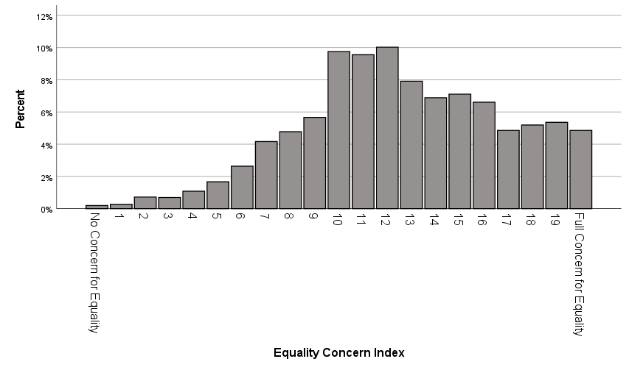

Feminist Attitude Index (XYFEMATTINDEX):
Six questions:
1.) When women demand equality these days, how often are they actually seeking special favors? Possible responses: always (coded as 0), most of the time (coded as 3), about half the time (coded as 6), some of the time (coded as 9), never (coded as 12)
2.) When women complain about discrimination, how often do they cause more problems than
they solve? Possible responses: always (coded as 0), most of the time (coded as 3), about half the time (coded as 6), some of the time (coded as 9), never (coded as 12)
3.) How much attention should media pay to discrimination against women? Possible responses:
a great deal more attention (coded as 12), somewhat more attention (coded as 10), a little more attention (coded as 8), same amount of attention (coded as 6), a little less attention (coded as 4), somewhat less attention (coded as 2), a great deal less attention (coded as 0)
4.) How important is it that more women be elected to political office? Possible responses: Extremely important (coded as 12), very important (coded as 9), moderately important (coded as 6), a little important (coded as 3), or not important at all (coded as 0)
5.) Is it _____ for mothers who work outside the home to establish a warm and secure relationship with their children? Possible responses: a great deal easier (coded as 12), somewhat easier (coded as 10), slightly easier (coded as 8), neither easier nor harder (coded as 6), slightly harder (coded as 4), somewhat harder (coded as 2), a great deal harder (coded as 0)
6.) Do you think it is ______ for the family as a whole if the man works outside the home and the woman takes care of the home and family? Possible responses: much better (coded as 0), somewhat better (coded as 2), slightly better (coded as 4), makes no difference (coded as 6), slightly worse (coded as 8), somewhat worse (coded as 10), much worse (coded as 12)

Combining these six questions results in an index that theoretically ranges from 0 = no feminist attitudes, up to 72 = full feminist attitudes. In reality, the resulting index ranges from 4 to 66, as there were no respondents at the theoretical extremes.

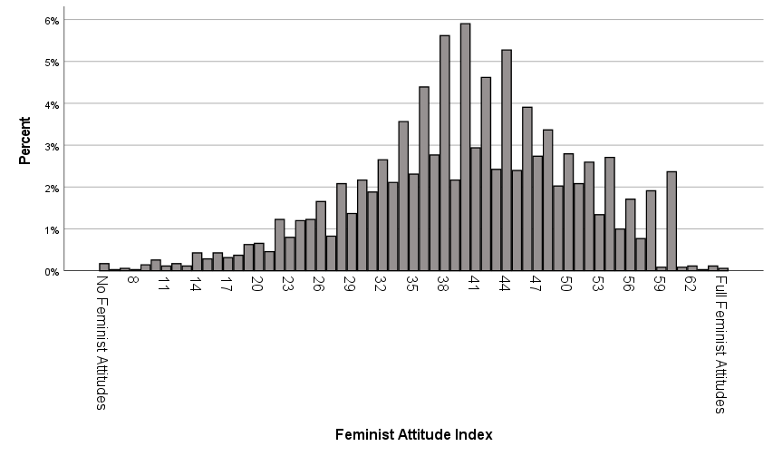

Feminist Identity Index (XYFEMIDINDEX):
Two questions:
1.) Do you consider yourself a strong feminist (coded as 4), a feminist (coded as 2) or are you not a feminist (coded as 0)?
2.) How well does the term feminist describe you? Extremely well (coded as 4), very well (coded as 3), somewhat well (coded as 2), not very well (coded as 1), not at all (coded as 0)

Combining these results in an index that ranges from 0 = not at all a feminist, up to 8 = strong feminist identification.

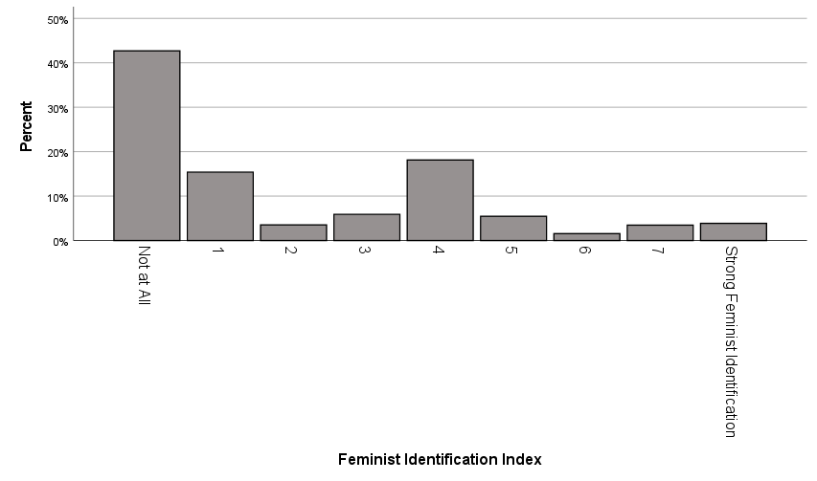

Gay/Lesbian Policy Support Index (XYGLPOLINDEX):
Three questions that had different numbers of response categories:
Do you think gay or lesbian couples should be legally permitted to adopt children? (yes = 6, no = 0)
Do you favor or oppose laws to protect gays and lesbians against job discrimination?
(favor strongly = 6, favor not strongly = 4, oppose not strongly = 2, oppose strongly = 0)
Which comes closest to your view? Gay and lesbian couples should be allowed to legally marry (6), gay and lesbian couples should be allowed to form civil unions but not legally marry (3), there should be no legal recognition of a gay or lesbian couple’s relationship. (0)

Putting these together results in an index where 0 = no policy support for gays and lesbians, up to 18 = full policy support for gays and lesbians.
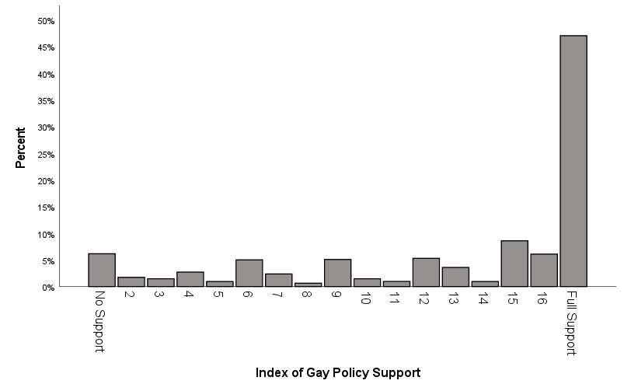

Health Care Law Support Index (XYHLTHCRINDEX):
Four questions that started:
Has the 2010 health care law, also known as the Affordable Care Act, improved, worsened, or had no effect on…
…the quality of health care services in the United States?
…the number of Americans with health insurance?
…the cost of health insurance for most Americans?
…the cost of your health care?
Worsened was coded as 0, no effect as 3, and improved as 6.
One additional question:
Do you favor, oppose, or neither favor nor oppose the health care reform law passed in 2010? This law requires all Americans to buy health insurance and requires health insurance companies to accept everyone.
This question was coded from 0 (no support) to 6 (full support).

Putting these together results in an index that ranges from 0 = no support for Obamacare, to 30 = full support for Obamacare.

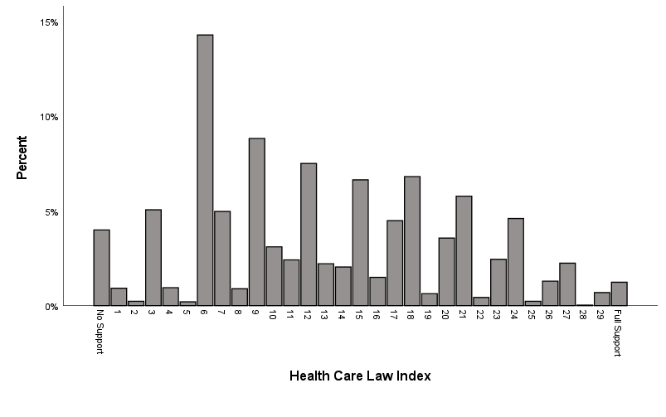

Immigration Action Index (XYIMMDOINDEX):
Five questions:
1.) Some people have proposed that the U.S. Constitution should be changed so that the children of unauthorized immigrants do not automatically get citizenship if they are born in this country. Possible responses: favor a great deal (coded as 0), favor a moderate amount (coded as 1), favor a little (coded as 2), neither favor or oppose (coded as 3), oppose a little (coded as 4), oppose a moderate amount (coded as 5), oppose a great deal (coded as 6)
2.) What should happen to immigrants who were brought to the U.S. illegally as children and have lived here for at least 10 years and graduated high school here? Should they be sent back where they came from, or should they be allowed to live and work in the United States? Possible responses: should send back – favor a great deal (coded as 0), should send back – favor a moderate amount (coded as 1), should send back – favor a little (coded as 2), should allow to stay – favor a little (coded as 4), should allow to stay – favor a moderate amount (coded as 5), should allow to stay – favor a great deal (coded as 6)
3.) Do you think the number of immigrants from foreign countries who are permitted to come to the United States to live should be… possible responses: increased a lot (coded as 6), increased a little (coded as 5), left the same as it is now (coded as 3), decreased a little (coded as 1), decreased a lot (coded as 0)
4.) Which comes closest to your view about what government policy should be toward unauthorized immigrants now living in the United States? possible responses: make all unauthorized immigrants felons and send them back to their home country (coded as 0), have a guest worker program in order to work (coded as 2), allow to remain and eventually quality for U.S. citizenship, if they meet criteria (coded as 4), allow to remain and eventually qualify for U.S. citizenship without penalties (coded as 6)
5.) Do you favor, oppose, or neither favor nor oppose building a wall on the U.S. border with Mexico? possible responses: favor a great deal (coded as 0), favor a moderate amount (coded as 1), favor a little (coded as 2), neither favor nor oppose (coded as 3), oppose a little (coded as 4), oppose a moderate amount (coded as 5), oppose a great deal (coded as 6)

Combining these variables results in an index ranging from 0 = act against immigrants, up to 30 = act for immigrants.

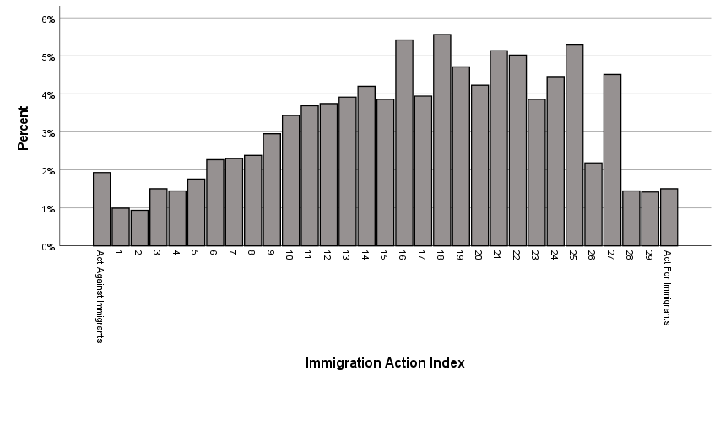

Immigration Attitude Index (XYIMMATTINDEX):
Four questions:
1.) Immigrants increase crime rates in the United States. Possible responses: agree strongly (coded as 0), agree somewhat (coded as 1), neither agree nor disagree (coded as 2), disagree somewhat (coded as 3), disagree strongly (coded as 4)
2.) America’s culture is generally harmed by immigrants. Possible responses: agree strongly (coded as 0), agree somewhat (coded as 1), neither agree nor disagree (coded as 2), disagree somewhat (coded as 3), disagree strongly (coded as 4)
3.) Immigrants are generally good for America’s economy. Possible responses: agree strongly (coded as 4), agree somewhat (coded as 3), neither agree nor disagree (coded as 2), disagree somewhat (coded as 1), disagree strongly (coded as 0)
4.) How likely is it that recent immigration levels will take jobs away from people already here?
Possible responses: extremely likely (coded as 0), very likely (coded as 1), somewhat likely (coded as 3), not at all likely (coded as 4)

Combining these variables results in an index ranging from 0 = no support for immigrants, up to 16 = full support for immigrants).

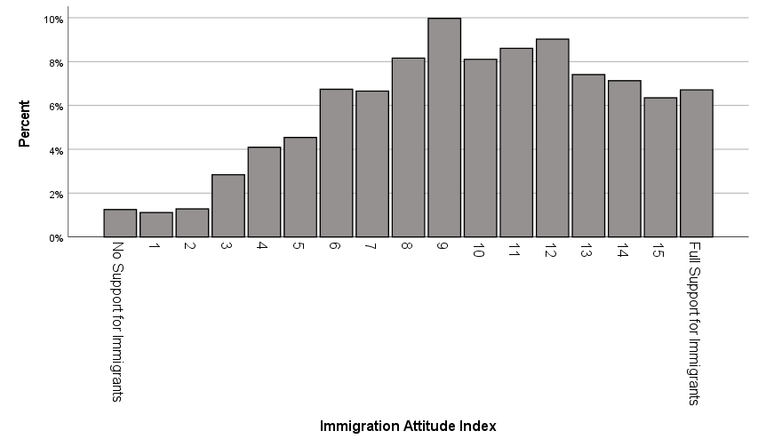

Mobility Possibility Index (XYMOBINDEX):
Two questions:
1.) When it comes to people trying to improve their financial well-being, do you think it is now easier, harder, or the same as it was 20 years ago? Possible responses: a great deal easier (coded as 6), a moderate amount easier (coded as 5), a little easier (coded as 4), the same (coded as 3), a little harder (coded as 2), a moderate amount harder (coded as 1), a great deal harder (coded as 0)
2.) How much opportunity is there in America today for the average person to get ahead? Possible responses: a great deal (coded as 6), a lot (coded as 5), a moderate amount (coded as 3), a little (coded as 1), none (coded as 0)

Combining these variables results in an index ranging from 0 = there is no possibility for mobility, up to 12 = there is plenty of mobility.

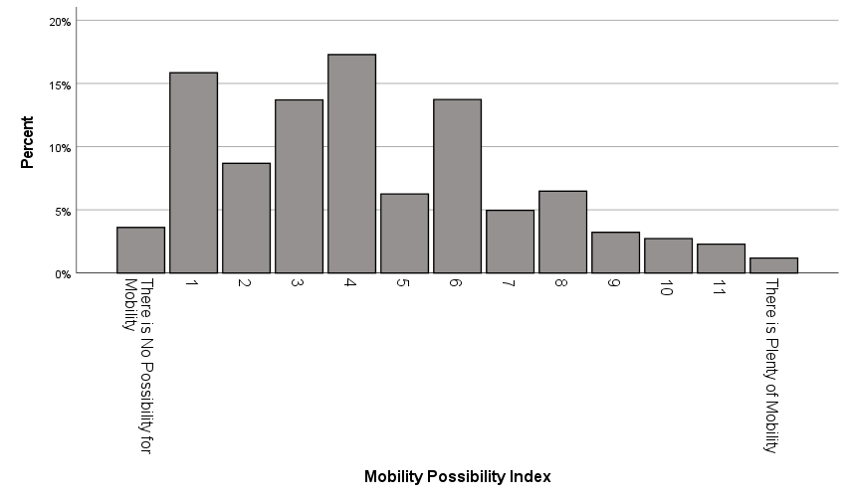

Muslim Negative Stereotypes Index (XYSTXNMSLMINDEX):
Set of four questions, asking the respondents to rate groups on one 0-to-6-point scale from violent to peaceful, and another 0-to-6-point scale from unpatriotic to patriotic. Combining responses about Christians and Muslims, the resulting index ranges from negative 12 =
very negative views of Muslims and very positive views of Christians, up to positive 12 = very negative views of Christians and very positive views of Muslims. Even though the highest possible score was 12, the highest actual score was 11.

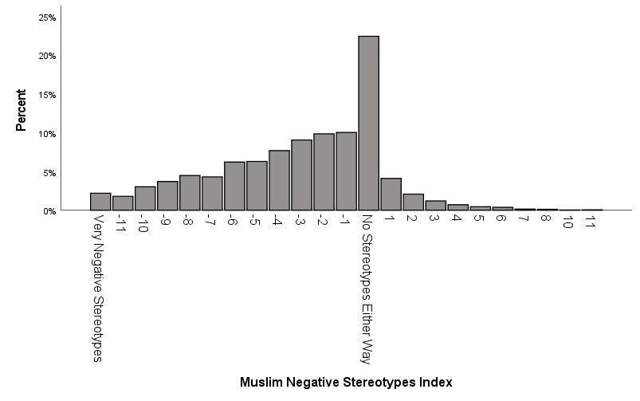

Nativism Index (XYPATRIOTINDEX):
Four questions that started:
Some people say that the following things are important for being truly American. Others says they are not important. How important do you think the following is for being truly American...
…to have been born in the United States.
…to have American ancestry.
…to be able to speak English.
…to follow America’s customs and traditions.
The response categories were: very important, fairly important, not very important, and not important at all, which were coded 3, 2, 1, and 0 accordingly.

This results in an index ranging from 0 = not nativist, up to 12 = very nativist.

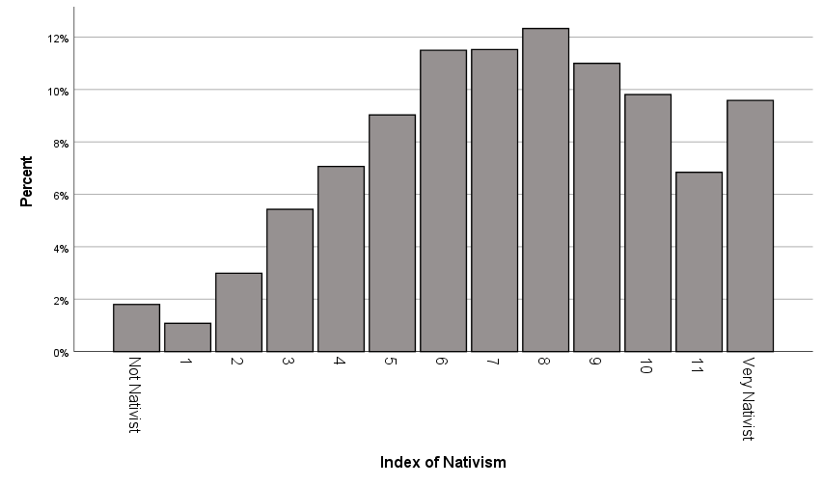

Political Agency Index (XYPOLAGINDEX):
Four questions:
1.) Public officials don’t care much what people like me think. Responses options: agree strongly (coded as 0), agree somewhat (coded as 1), neither agree nor disagree (coded as 2), disagree somewhat (coded as 3), disagree strongly (coded as 4).
2.) People like me don’t have any say about what the government does. Responses options: agree strongly (coded as 0), agree somewhat (coded as 1), neither agree nor disagree (coded as 2), disagree somewhat (coded as 3), disagree strongly (coded as 4).
3.) How often do politics and government seem so complicated that you can’t really understand
what’s going on? Response options: always (coded as 0), most of the time (coded as 1), about half the time (coded as 2), some of the time (coded as 3), never (coded as 4).
4.) How well do you understand the important political issues facing our country? Responses options: extremely well (coded as 4), very well (coded as 3), moderately well (coded as 2), slightly well (coded as1), not well at all (coded as 0).

This results in an index ranging from 0 = no political agency, up to 16 = full political agency.

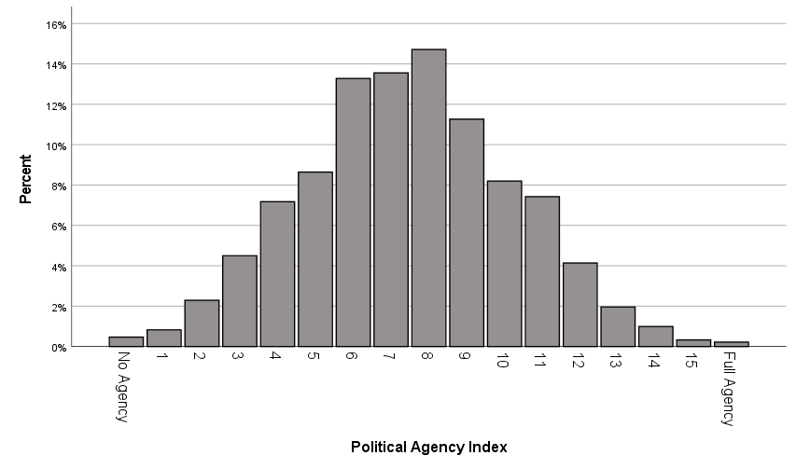

Political Knowledge Index (XYPOLKNOWINDEX2):
A set of nine questions about the American political system and the identity of political figures, ranging from 0 = no knowledge, up to 9 = full knowledge.

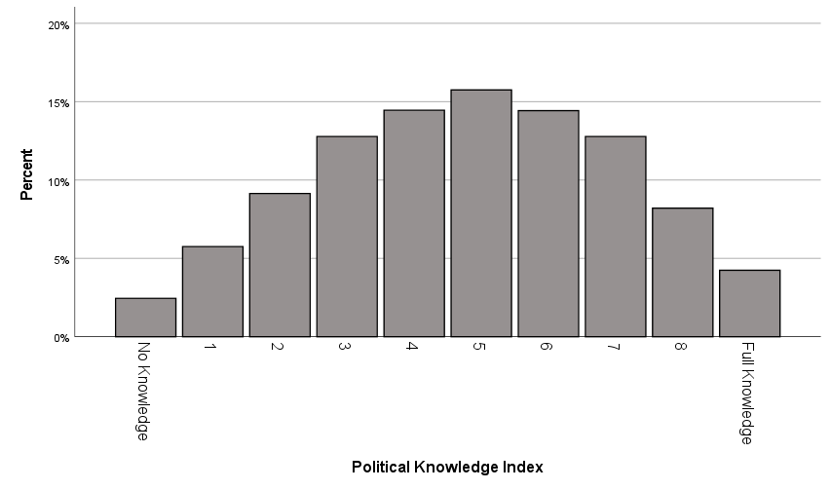

Presidential Job Index (XYPRESINDEX):
Four questions that started:
Do you approve or disapprove of the way Barack Obama is handling…
…his job as President?
…the economy?
…relations with foreign countries?
…health care?
The response categories were: approve strongly (coded as 3), approve not strongly (coded as 2), disapprove not strongly (coded as 1), disapprove strongly (coded as 0).

This results in an index ranging from 0 = strongly disapprove of Obama’s job performance, up to 12 = strongly approve of Obama’s job performance.

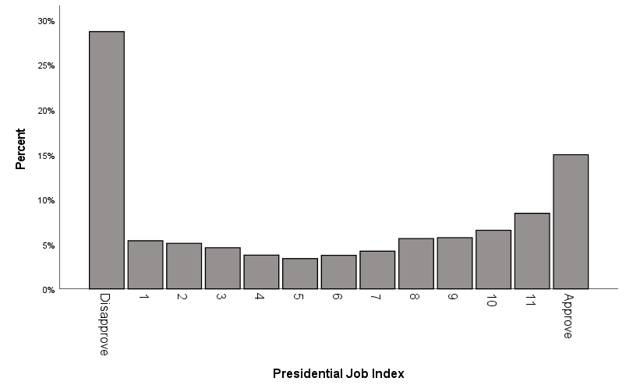

Safety Net Budget Index (XYBUDGINDEX):
Five questions, each reading: Should federal spending on _____ be increased, decreased, or kept the same?
1.) child care
2.) aid to the poor
3.) public schools
4.) Social Security
5.) welfare programs
Increased was coded as 2, kept the same as 1, and decreased as 0, resulting in an index ranging from 0 = decrease spending, up to 10 = increase spending.

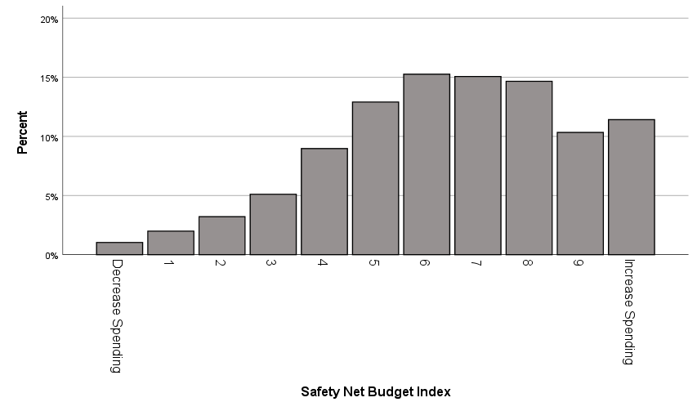

Traditionalism Index (XYTRADINDEX):
Five statements, to which respondents were asked to choose from: agree strongly, agree somewhat, neither agree nor disagree, disagree somewhat, disagree strongly.
1.) The world is always changing and we should adjust our view of moral behavior to those
changes. (agree strongly = 0)
2.) The newer lifestyles are contributing to the breakdown of our society. (agree strongly = 4)
3.) We should be more tolerant of people who choose to live according to their own moral
standards, even if they are very different from our own. (agree strongly = 0)
4.) This country would have many fewer problems if there were more emphasis on traditional
family ties. (agree strongly = 4)
5.) Minorities should adapt to the customs and traditions of the United States. (agree strongly = 4)

Combining these results in an index that ranges from 0 = Very non-traditional, up to 20 = very traditional.

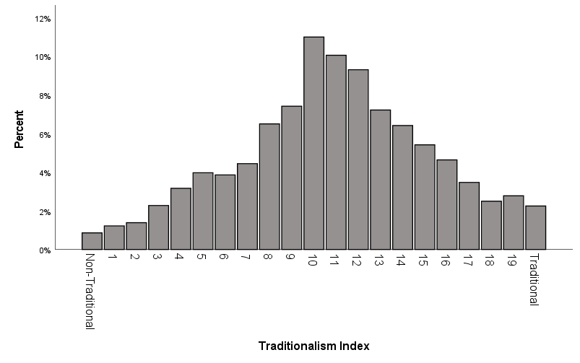

Vaccine Index (XYVACCINDEX):
Two questions, each with seven possible responses:

Requiring children to be vaccinated in order to attend public schools:
Favor a great deal (coded as 6), favor a moderate amount (coded as 5), favor a little (coded as 4), neither favor nor oppose (coded as 3), oppose a little (coded as 2), oppose a moderate amount (coded as 1), oppose a great deal (coded as 0).

Do the health benefits of vaccinations generally outweigh the risks, do the risks outweigh the benefits?
Benefits much greater (coded as 6), benefits moderately greater (coded as 5), benefits slightly greater (coded as 4), no difference (coded as 3), risks slightly greater (coded as 2), risks moderately greater (coded as 1), risks much greater (coded as 0).

Combining these results in an index that ranges from 0 = no support for vaccines, up to 12 = full support for vaccines.

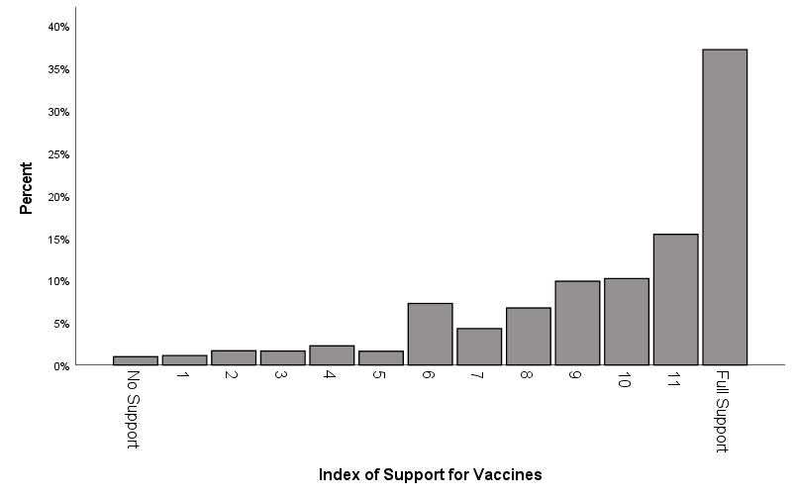

Vocabulary Index (XYVOCABINDEX):
Respondents were given a ten-word vocabulary quiz.
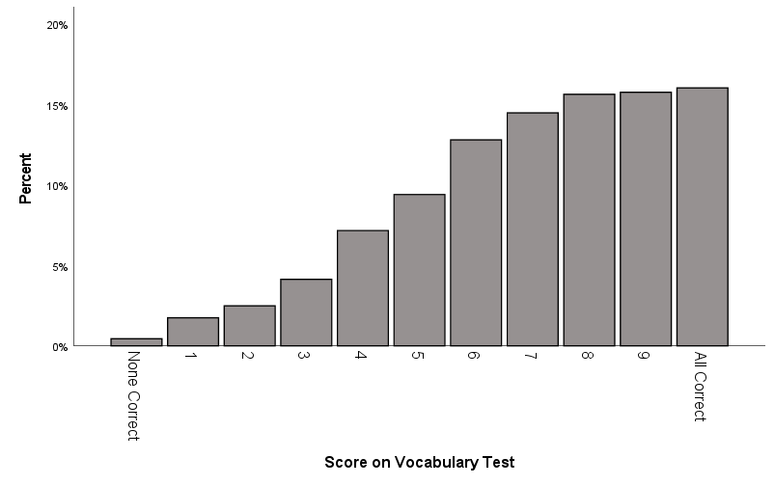
INTERACTION EFFECTS

XYINTGENDEREDUC: An interaction effect that multiplies XYGENDER (the recoded gender variable) and XYEDUC (the recoded education variable).

XYINTRACEWBEDUC: An interaction effect that multiplies XYRACEWB (the dichotomous recoded race variable) and XYEDUC (the recoded education variable).

XYINTRACEWBFTLIB: An interaction effect that multiplies XYRACEWB (the dichotomous recoded race variable) and the feeling thermometer toward liberals.

XYINTRACEWBFTCONS: An interaction effect that multiplies XYRACEWB (the dichotomous recoded race variable) and the feeling thermometer toward conservatives.

XYINTGENDERCHLDHS: An interaction effect that multiplies XYGENDER (the recoded gender variable) and CHILDINHOUSE (the number of children in the household).

SQUARED VARIABLES

XYEDUCSQ: The square of XYEDUC (the recoded education variable: years of education).

XYINCOMESQ: The square of XYINCOME (the recoded income variable: income in $1,000s).

XYATTENDSQ: The square of XYATTEND (the recoded religious attendance variable: number of times attend religious services per month).

XYPARTYIDSQ: The square of XYPARTYID (the recoded party identification variable).

XYAGESQUARED: The square of AGE (age in years).

UNIQUE GROUPS

In order to conduct analyses on a small number of cases, I located several unique groups within the ANES dataset by combining variables. Each of these were coded 1 if they were a member of this group and 0 if they were not a member of this group.

XYUNIQLESBITRUMP: Lesbian or bisexual women who voted for Donald Trump

XYUNIQOLDERNATIVEAM: Native Americans over 50 years old

XYUNIQTERF: Trans Exclusionary Radical Feminists (those who rated transgender people at 0 on the feeling thermometer while rating feminists at 100 on the feeling thermometer)

XYUNIQFERT: Feminist Exclusionary Radical Trans-supporters (those who rated transgender people at 100 on the feeling thermometer while rating feminists at 0 on the feeling thermometer)

XYUNIQFEMPOLICE: Women who have been arrested but still rate police at 100 on the feeling thermometer

XYUNIQUEUPPERPOOR: People who identify as upper class but have low incomes

XYUNIQYOUNGLAND: Young people who have only landlines and no cellphones

Variables from the 2020 American National Election Study
Variables from this dataset are used in the end-of-chapter exercises.

PERSONAL INFORMATION

CASEID: a case identification number for the respondent

AGE: age of the respondent in years

XYAGE4CAT: recoded from the AGE variable. Age in four categories: 18-36 (coded as 0), 37-52 (coded as 1), 53-65 (coded as 2), 66 & up (coded as 3)

EDUCSELF: education level of the respondent: Less than high-school credential (coded as 1), High-school credential (coded as 2), Some post-high school (coded as 3), Bachelor’s degree (coded as 4), Graduate degree (coded as 5)

A set of four reference-group variables recoded from the original EDUCSELF variable, where “some post high school” is the reference group:
XYEDREFSELFLTHS: Less than high school coded as 1, all others coded as 0
XYEDREFCSELFHS: High school coded as 1, all others coded as 0
XYEDREFSELFBACH: Bachelor’s degree coded as 1, all others coded as 0
XYEDREFSELFGRAD: Graduate degree coded as 1, all others coded as 0

EDUCSPOUSE: education level of the respondent’s spouse: Less than high-school credential (coded as 1), High-school credential (coded as 2), Some post-high school (coded as 3), Bachelor’s degree (coded as 4), Graduate degree (coded as 5)
SEX: sex of respondent: Male coded as 1, Female coded as 2
XYSEX: recoded from the SEX variable: Male coded as 0, Female coded as 1

HRSWORK: How many hours the respondent works per week

STOCKS: Do you personally, or jointly with a spouse, have any money invested in the stock market right now - either in an individual stock or in a mutual fund? Yes coded as 1, No coded as 0

INCOME: respondent’s income: Under $9,999 (coded as 1), $10,000-14,999 (coded as 2), $15,000-19,999 (coded as 3), $20,000-24,999 (coded as 4), $25,000-29,999 (coded as 5), $30,000-34,999 (coded as 6), $35,000-39,999 (coded as 7), $40,000-44,999 (coded as 8), $45,000-49,999 (coded as 9), $50,000-59,999 (coded as 10), $60,000-64,999 (coded as 11),
$65,000-69,999 (coded as 12), $70,000-74,999 (coded as 13), $75,000-79,999 (coded as 14),
$80,000-89,999 (coded as 15), $90,000-99,999 (coded as 16), $100,000-109,999 (coded as 17),
$110,000-124,999 (coded as 18), $125,000-149,999 (coded as 19), $150,000-174,999 (coded as 20), $175,000-249,999 (coded as 21), $250,000 or more (coded as 22)

INCOMEPOST: same as INCOME variable, but asked during the post-election survey

XYINCOME: recoded from INCOME variable, uses midpoints of each category (and $287,500) for the top category. This elicits a ratio-level variable of income in $1,000s.

XYINCOMEPOST: same as XYINCOME variable, but asked during the post-election survey

CLASS1: How would you describe your social class? Lower class (coded as 1), working class (coded as 2), middle class (coded as 3), upper class (coded as 4).

XYCLASSDICH: recoded from the CLASS1 variable, with Lower class and working class coded as 0, and middle class and upper class coded as 1

MARITAL: Are you now married, widowed, divorced, separated or never married? Married (coded as 1), married but spouse absent (coded as 2), widowed (coded as 3), divorced (coded as 4), separated (coded as 5), never married (coded as 6).

A set of three reference group variables where married is the reference group:
XYMARITALREFWID: where widowed is coded as 1, not widowed is coded as 0
XYMARITALREFDIVSEP: where divorced/separated is coded as 1, not divorced/separated is coded as 0
XYMARITALREFNEVER: where never married is coded as 1, not never married is coded as 0

RACE: respondent’s self-identified race/ethnicity: White, non-Hispanic (coded as 1), Black, non-Hispanic (coded as 2), Hispanic (coded as 3), Asian or Native Hawaiian/other Pacific Islander (coded as 4), Native American/Alaska Native or other race (coded as 5), Multiple races, non-Hispanic (coded as 6).

XYRACEWNW: recoded from the RACE variable, a dichotomous variable where not white is coded as 0 and white is coded as 1
XYRACEWB: recoded from the RACE variable, a dichotomous variable where white is coded as 0 and Black is coded as 1

A set of five reference-group variables recoded from the original RACE variable. White is the reference group.
XYRACEREFBLACK: Black (coded as 1), Not Black (coded as 0)
XYRACEREFHISP: Hispanic (coded as 1), Not Hispanic (coded as 0)
XYRACEREFASIAN: Asian (coded as 1), not Asian (coded as 0)
XYRACEREFNAT: Native American (coded as 1), Not Native American (coded as 0)
XYRACEREFMULT: Multiracial (coded as 1), Not multiracial (coded as 0)

BORNGRPAR: How many of your grandparents, if any, were born outside the U.S.?

CHILDS: How many children or teenagers age 0 to 17 live in this household?

XYLIFESAT: All things considered, how satisfied are you with your life as a whole these days?
Not satisfied at all (coded as 0), Slightly satisfied (coded as 1), Moderately satisfied (coded as 2), Very satisfied (coded as 3), Extremely satisfied (coded as 4)

XYLIFESATDICH: A dichotomous version of the life satisfaction variable: Not very satisfied (coded as 0), Very satisfied (coded as 1)

MEDPUTOFF: We are interested in finding out whether or not people are getting regular check ups and vaccinations as well as treatment for illness and injury. During the past 12 months, have you or anyone living here put off getting this kind of health care because of the cost, or has no one living here put off getting this kind of health care because of the cost? Someone has put off health care (coded as 1), No one has put off health care (coded as 2)

MEDHLTHCARE: During the next 12 months, how likely is it that you will be able to pay for all of your health care costs? Extremely likely (coded as 1), Very likely (coded as 2), Moderately likely (coded as 3), Slightly likely (coded as 4), Not likely at all (coded as 5)

FINWORRY: So far as you and your family are concerned, how worried are you about your current financial situation? Extremely worried (coded as 1), Very worried (coded as 2), Moderately worried (coded as 3), A little worried (coded as 4), Not at all worried (coded as 5)

HOMEOWN: Does your household make monthly mortgage payments for your home, or is the home owned outright with no payments due? Pay mortgage (coded as 1), Own home with no payments due (coded as 2).

FINHOUSE: During the next 12 months, how likely is it that you will be able to make all of your [rent/mortgage] payments on time? Extremely likely (coded as 1), Very likely (coded as 2), Moderately likely (coded as 3), Slightly likely (coded as 4), Not likely at all (coded as 5)

SEXORNT: Do you consider yourself to be heterosexual or straight, homosexual or gay [or lesbian], or bisexual? Heterosexual or straight (coded as 1), Homosexual or gay (or lesbian) (coded as 2), Bisexual (coded as 3), Something else (coded as 4)

XYSEXORNT: A recoded version of the SEXORNT variable where Heterosexual is coded as 0 and Not Heterosexual is coded as 1
GLKNOW: Among your immediate family members, relatives, neighbors, co-workers, or close friends, are any of them gay, lesbian, or bisexual as far as you know? Yes (coded as 1), No (coded as 2)

XYGLKNOW: A recoded version of GLKNOW where No is coded as 0 and Yes is coded as 1

TRANSKNOW: Among your immediate family members, relatives, neighbors, co-workers, or close friends, are any of them transgender as far as you know? Yes (coded as 1), No (coded as 2)

XYTRANSKNOW: A recoded version of TRANSKNOW where No is coded as 0 and Yes is coded as 1

ARREST: Have you ever been arrested, or has that never happened to you? Have been arrested (coded as 1), Never arrested (coded as 2)
XYARREST: a recoded version of the arrest variable, where Never arrested is coded as 0 and Have been arrested is coded as 1

POLICESTOP: During the past 12 months, were you or any of your family members stopped or questioned by a police officer, or did this not happen in the past 12 months? Was stopped or questioned in the past 12 months (coded as 1), Was not stopped or questioned in the past 12 months (coded as 2)
XYPOLICESTOP: A recoded version of the POLICESTOP variable where No is coded as 0, and Yes is coded as 1

HLTHCONC: In the past week, how often have you had trouble keeping your mind on what you were doing? All the time (coded as 1), Often (coded as 2), Sometimes (coded as 3), Rarely (coded as 4), Never (coded as 5)

HLTHSLEEP: In the past week, how often has your sleep been restless? All the time (coded as 1), Often (coded as 2), Sometimes (coded as 3), Rarely (coded as 4), Never (coded as 5)

HLTHINS: Do you presently have any kind of health insurance? Yes (coded as 1), No (coded as 0)

HLTHINSLOSE: How concerned are you about losing your health insurance in the next year? Not at all concerned (coded as 1), A little concerned (coded as 2), Moderately concerned (coded as 3), Very concerned (coded as 4), Extremely concerned (coded as 5)

HLTHPAY: How concerned are you about being able to pay health care expenses for you and your family in the next year? Not at all concerned (coded as 1), A little concerned (coded as 2), Moderately concerned (coded as 3), Very concerned (coded as 4), Extremely concerned (coded as 5)

HEALTH: Would you say that in general your health is excellent, very good, good, fair, or poor? Excellent (coded as 1), Very good (coded as 2), Good (coded as 3), Fair (coded as 4), Poor (coded as 5)

COVIDPOS: Has anyone in your household tested positive for the coronavirus disease, COVID-19, or has no one tested positive? Someone in my household tested positive (coded as 1), No one tested positive (coded as 2)

RURALURB: Do you currently live in a rural area, small town, suburb, or a city? Rural area (coded as 1), Small town (coded as 2), Suburb (coded as 3), City (coded as 4)

A set of three reference-group variables, where “rural area” is the reference group:
XYLOCREFTOWN: Town (coded as 1), Not Town (coded as 0)
XYLOCREFSUBURB: Suburb (coded as 1), Not Suburb (coded as 0)
XYLOCREFCITY: City (coded as 1), Not City (coded as 0)

SMOKE: Do you now smoke cigarettes every day, some days, or not at all? Every day (coded as 1), Some days (coded as 2), Not at all (coded as 3)

XYSMOKE: A recoded version of the SMOKE variable where No is coded as 0 and Yes is coded as 1

LANDLINE: Is there at least one telephone inside your home that is currently working and is not a cell phone? Yes (coded as 1), No (coded as 2)

PASSPORT: Do you now have a non-expired U.S. passport, or do you not have one? Have a valid US passport (coded as 1), Do not have one (coded as 2)

XYPASSPORT: A recoded version of the PASSPORT variable where Does not have a passport is coded as 0, and does have a passport is coded as 1

FACEBOOK: How often do you use Facebook? Many times every day (coded as 1), A few times every day (coded as 2), About once a day (coded as 3), A few times each week (coded as 4), About once a week (coded as 5), Once or twice a month (coded as 6), Less than once a month (coded as 7)

GUNS: How many guns do you or anyone else living here own?

RELIGION

RELIMP: How important is religion in your life? Extremely important (coded as 1), Very important (coded as 2), Moderately important (coded as 3), A little important (coded as 4), Not important at all (coded as 5)

RELIGDEN: Major group religion summary. Mainline Protestant (coded as 1), Evangelical Protestant (coded as 2), Black Protestant (coded as 3), Undifferentiated Protestant (coded as 4), Roman Catholic (coded as 5), Other Christian (coded as 6), Jewish (coded as 7), Other religion (coded as 8), Not religious (coded as 9)

BIBLE: Which of these statements comes closest to describing your feelings about the Bible?
The Bible is the actual word of God and is to be taken literally, word for word (coded as 1), the Bible is the word of God but not everything in it should be taken literally (coded as 2), the Bible is a book written by men and is not the word of God (coded as 3).

XYBIBLEREFLIT: a reference-group variable where literal is coded as 1 and everyone else is coded as 0.

XYBIBLEREFMEN: a reference-group variable where book written by men is coded as 1 and everyone else is coded as 0.

ATTENDEVER: Lots of things come up that keep people from attending religious services even if they want to. Thinking about your life these days, do you ever attend religious services, apart from occasional weddings, baptisms or funerals? Yes (coded as 1), no (coded as 2).

ATTENDOFT: If answered yes to ATTENDEV: Do you go to religious services every week, almost every week, once or twice a month, a few times a year, or never? Every week (coded as 1), almost every week (coded as 2), once or twice a month (coded as 3), a few times a year (coded as 4), never (coded as 5).

ATTENDLOTS: If answered every week to ATTENDOFT: Would you say you go to religious services once a week or more often than once a week? Once a week (coded as 1), more than once a week (coded as 2).

XYATTEND: Combines ATTENDEV, ATTENDOFT, and ATTENDLOT to create a variable that is the number of times the respondent attends religious services per month.

RELIG: Major group religion summary. Mainline Protestant (coded as 1), Evangelical Protestant (coded as 2), Black Protestant (coded as 3), Catholic (coded as 4), Undifferentiated Christian (coded as 5), Jewish (coded as 6), other religion (coded as 7), not religious (coded as 8).

POLITICAL ENGAGEMENT

POLATT: How often do you pay attention to what’s going on in government and politics? Always (coded as 1), Most of the time (coded as 2), About half of the time (coded as 3), Some of the time (coded as 4), Never (coded as 5)

POLINT: How interested would you say you are in politics? Are you very interested, somewhat interested, not very interested, or not at all interested? Very interested (coded as 1), Somewhat interested (coded as 2), Not very interested (coded as 3), Not at all interested (coded as 4)

CAMPINT: Some people don’t pay much attention to political campaigns. How about you? Would you say that you have been very much interested, somewhat interested or not much interested in the political campaigns so far this year? Very much interested (coded as 1), Somewhat interested (coded as 2), Not much interested (coded as 3)

POLVIEWS: Where would you place yourself on this scale, or haven’t you thought much about this? Extremely liberal (coded 1), liberal (coded 2), slightly liberal (coded 3), moderate (coded 4), slightly conservative (coded 5), conservative (coded 6), extremely conservative (coded 7)

XYPOLVIEWS: recoded version of POLVIEWS, where extremely liberal is coded as 0, liberal as 1, etc

PARTYID: Generally speaking, do you usually think of yourself as… strong Democrat (coded as 1), not very strong Democrat (coded as 2), Independent Democrat (coded as 3), Independent (coded as 4), Independent Republican (coded as 5), not very strong Republican (coded as 6), strong Republican (coded as 7)

XYPARTYID: recoded version of PARTYID, where strong Democrat is coded as 0, not very strong Democrat as 1, etc

POLDISCDAYS: How many days in the past week did you talk about politics with family or friends?

XYPOLDISCDAYS: Combines the above question with a previous question asking if they discuss politics at all

VOTEDID: How about the election for President? Did you vote for a candidate for President? Yes (coded as 1), No (coded as 2)

VOTEWHO: For whom did respondent vote for president? Joe Biden (coded as 1), Donald Trump (coded as 2)

VOTESTRGTH: Would you say your preference for this candidate is strong or
not strong? Strong (coded as 1), Not strong (coded as 2)

GOVCARE: Public officials don’t care much what people like me think. Do you agree strongly, agree somewhat, neither agree nor disagree, disagree somewhat, or disagree strongly with this
statement? Agree strongly (coded as 1), Agree somewhat (coded as 2), Neither agree not disagree (coded as 3), Disagree somewhat (coded as 4), Disagree strongly (coded as 5)

POLFAMILY: In the past four years, how much have political differences hurt your relationships with family members? A great deal (coded as 1), A lot (coded as 2), A moderate amount (coded as 3), A little (coded as 4), Not at all (coded as 5)

XYKNOWINDEX: an index of the respondent’s ability to identify various national and world leaders, ranges from 0 (no knowledge) to 10 (full knowledge)

VARIOUS ATTITUDES

TRUST: Generally speaking, how often can you trust other people? Always (coded as 1), Most of the time (coded as 2), About half the time (coded as 3), Some of the time (coded as 4), Never (coded as 5)

ABORTION: There has been some discussion about abortion during recent years. Which one of the opinions on this page best agrees with your view? By law, abortion should never be permitted (coded as 1), By law, only in case of rape, incest, or woman’s life in danger (coded as 2), By law, for reasons other than rape, incest, or woman’s life in danger if need established (coded as 3), By law, abortion as a matter of personal choice (coded as 4)

XYABORTIONDICH: Restriction abortion (coded as 0), Do not restrict abortion (coded as 1)

ABIMP: How important is the issue of abortion to you personally? Not at all important (coded as 1), Not too important (coded as 2), Somewhat important (coded as 3), Very important (coded as 4), Extremely important (coded as 5)

DEATHPEN: Do you favor or oppose the death penalty for persons convicted of murder? Favor strongly (coded as 1), Favor not strongly (coded as 2), Oppose not strongly (coded as 3), Oppose strongly (coded as 4)

ISOLATE: Do you agree or disagree with this statement: This country would be better off if we just stayed home and did not concern ourselves with problems in other parts of the world. Agree strongly (coded as 1), Agree somewhat (coded as 2), Disagree somewhat (coded as 3), Disagree strongly (coded as 4)

MEDIATRUST: In general, how much trust and confidence do you have in the news media when it comes to reporting the news fully, accurately, and fairly? None (coded as 1), A little (coded as 2), A moderate amount (coded as 3), A lot (coded as 4), A great deal (coded as 5)

PROTVIOL: During the past few months, would you say that most of the actions taken by protestors to get the things they want have been violent, or have most of these actions by protesters been peaceful, or have these actions been equally violent and peaceful? A lot more violent (coded as 1), A little more violent (coded as 2), Equally violent and peaceful (coded as 3), A little more peaceful (coded as 4), A lot more peaceful (coded as 5)

AFFACT: What about your opinion – are you for or against preferential hiring and promotion of blacks? Strongly for preferential hiring/promotion of blacks (coded as 1), Not strongly for preferential hiring/promotion of blacks (coded as 2), Not strongly against preferential hiring/promotion of blacks (coded as 3), Strongly against preferential hiring/promotion of blacks (coded as 4).

CHILDTRAIT1: Please tell me which one you think is more important for a child to have: Independence or respect for elders? Independence (coded as 1), Respect for others (coded as 2)

CHILDTRAIT2: Which one is more important for a child to have: Curiosity or good manners? Curiosity (coded as 1), Good manners (coded as 2)

CHILDTRAIT3: Which one is more important for a child to have: Obedience or self-reliance?
Obedience (coded as 1), Self-reliance (coded as 2)

XYCHILDTRAIT3: Which one is more important for a child to have: Obedience or self-reliance? Obedience (coded as 0), Self-reliance (coded as 1)

CHILDTRAIT4: Which one is more important for a child to have: Being considerate or well behaved? Being considerate (coded as 1), Well behaved (coded as 2)

FEMINIST: Do you consider yourself a feminist, an anti-feminist, or neither of these? Feminist (coded as 1), Anti-feminist (coded as 2), Neither (coded as 3)

FEELING THERMOMETERS
Before being asked these questions, the respondents received this explanation: Ratings between 50 degrees and 100 degrees mean that you feel favorable and warm toward the group. Ratings between 0 degrees and 50 degrees mean that you don’t feel favorable toward the group and that you don’t care too much for that group. You would rate the group at the 50-degree mark if you don’t feel particularly warm or cold toward the group.

Joe Biden (pre-election)
Donald Trump (pre-election)
Joe Biden (post-election)
Donald Trump (post-election)
Barack Obama
Democrats
Republicans
Anthony Fauci
Christian Fundamentalists
Liberals
Labor movement
Big business
Conservatives
Supreme Court
Gays and lesbians
Congress
Muslims
Christians
Jews
Police
Transgender people
Scientists
Black Lives Matter
Journalists
Socialists
Capitalists
ICE
The #MeToo Movement
Asian Americans
Asians
Hispanics
Blacks
Illegal immigrants
Whites

INDEXES

Index of Support for COVID-19 Restrictions (XYCOVIDINDEX):
Three questions:
1.) Do you think the federal government’s response to the COVID-19 outbreak earlier this year was too quick, too slow, or about right? Much too quick (coded as 0), Somewhat too quick (coded as 1), About right (coded as 2), Somewhat too slow (coded as 3), Much too slow (coded as 4)
2.) Do you think the limits your state placed on public activity because of the COVID-19 pandemic were far too strict, somewhat too strict, about right, not quite strict enough, or not
nearly strict enough? Far too strict (coded as 0), Somewhat too strict (coded as 1), About right (coded as 2), Not quite strict enough (coded as 3), Not nearly strict enough (coded as 4)
3.) Do you think your state has moved too quickly, too slowly, or the right speed in relaxing stay-at-home orders and reopening businesses? Much too slowly (coded as 0), Somewhat too slowly (coded as 1), About right (coded as 2), Somewhat too quickly (coded as 3), Much too quickly (coded as 4)

Combining these variables results in an index ranging from 0 = no support, up to 12 = full support.

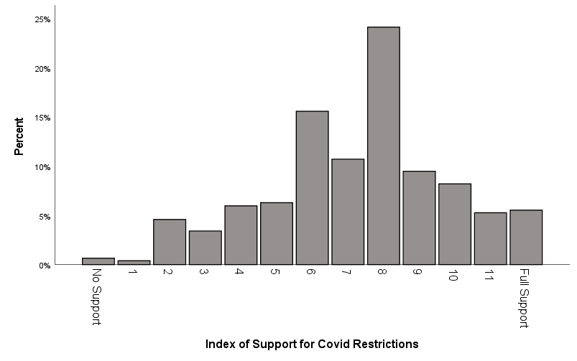

Index of American Nativism (XYAMERINDEX)
Four questions:
Some people say that the following things are important for being truly American. Others says they are not important. How important do you think the following is for being truly
American:
1.) To have been born in the United States
2.) To have American ancestry
3.) To be able to speak English
4.) To follow American customs and traditions
All of these variables had the same possible responses: Not important at all (coded as 0), Not very important (coded as 1), Fairly important (coded as 2), Very important (coded as 3).

Combining these variables results in an index ranging from 0 = not nativist, up to 12 = very nativist.

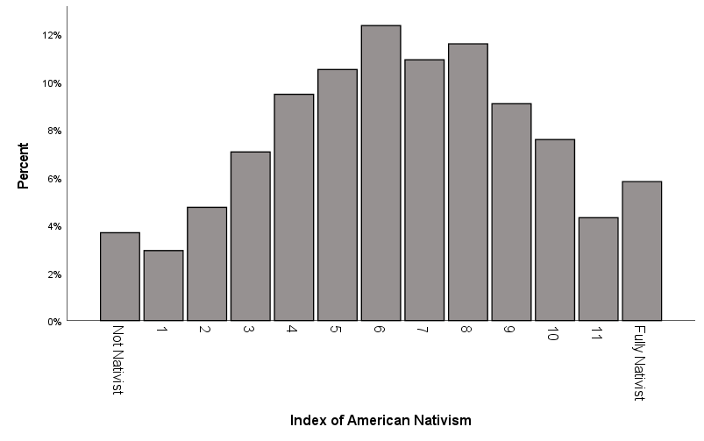

Index of Support for Black Americans
Four questions:
1.) Irish, Italian, Jewish and many other minorities overcame prejudice and worked their way up. Blacks should do the same without any special favors. Agree strongly (coded as 0), Agree somewhat (coded as 1), Neither agree nor disagree (coded as 2), Disagree somewhat (coded as 3), Disagree strongly (coded as 4)
2.) Generations of slavery and discrimination have created conditions that make it difficult for blacks to work their way out of the lower class. Agree strongly (coded as 4), Agree somewhat (coded as 3), Neither agree nor disagree (coded as 2), Disagree somewhat (coded as 1), Disagree strongly (coded as 0)
3.) Over the past few years, blacks have gotten less than they deserve. Agree strongly (coded as 4), Agree somewhat (coded as 3), Neither agree nor disagree (coded as 2), Disagree somewhat (coded as 1), Disagree strongly (coded as 0)
4.) It’s really a matter of some people not trying hard enough; if blacks would only try harder they could be just as well off as whites. Agree strongly (coded as 0), Agree somewhat (coded as 1), Neither agree nor disagree (coded as 2), Disagree somewhat (coded as 3), Disagree strongly (coded as 4)

Combining these variables results in an index ranging from 0 = no support, up to 16 = full support.

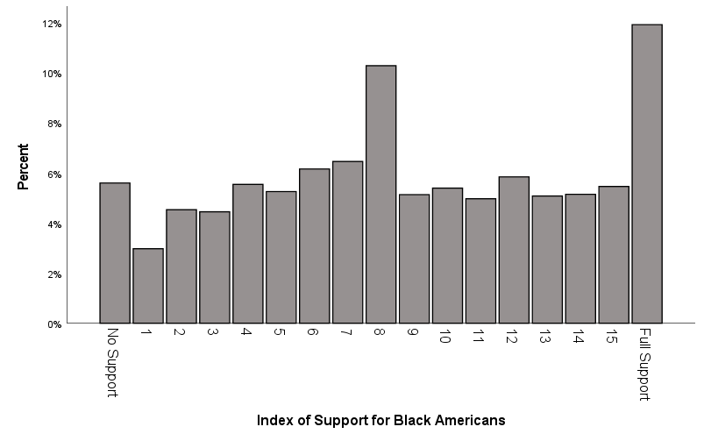

Index of Support for Gays and Lesbians
Four questions:
1.) Do you think gay or lesbian couples should be legally permitted to adopt children? No (coded
as 0), Yes (coded as 1)
2.) Do you favor or oppose laws to protect gays and lesbians against job discrimination? Oppose strongly (coded as 0), Oppose not strongly (coded as .33), Favor not strongly (coded as .67), Favor strongly (coded as 1)
3.) Which comes closest to your view? Gay and lesbian couples should be allowed to legally marry (coded as 1), Gay and lesbian couples should be allowed to form civil unions but not legally marry (coded as .50), There should be no legal recognition of gay or lesbian
couples’ relationship (coded as 0)
4.) Do you think business owners who provide wedding-related services should be allowed to refuse services to same-sex couples if same-sex marriage violates their religious beliefs, or do you think business owners should be required to provide services regardless of a couple’s sexual orientation? Feels very strongly should be allowed to refuse services (coded as 0), Feels moderately strongly should be allowed to refuse services (coded as.2), Feels a little strongly should be allowed to refuse services (coded as .4), Feels a little strongly should be required to provide services (coded as .6), Feels moderately strongly should be required to provide services (coded as .8), Feels very strongly should be required to provide services (coded as 1)

Combining these variables results in an index ranging from 0 = no support, up to 4 = full support.

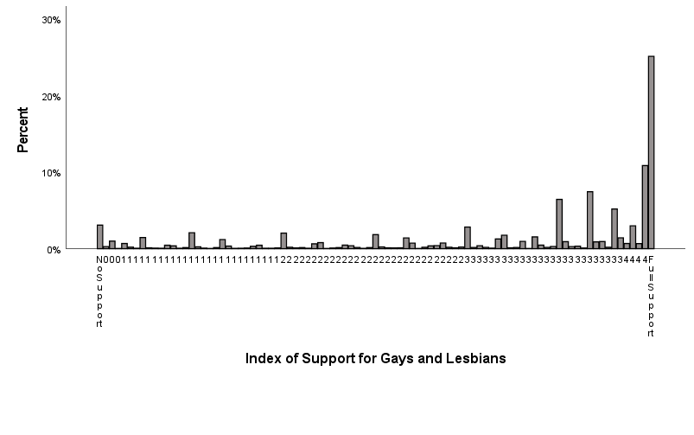

Index of Equality Concern
Four questions:
1.) It is not really that big a problem if some people have more of a chance in life than others.
Agree Strongly (coded as 0), Agree somewhat (coded as 1), Neither agree nor disagree (coded as 2), Disagree somewhat (coded as 3), Disagree strongly (coded as 4)
2.) If people were treated more equally in this country we would have many fewer problems. Agree Strongly (coded as 4), Agree somewhat (coded as 3), Neither agree nor disagree (coded as 2), Disagree somewhat (coded as 1), Disagree strongly (coded as 0)
3.) Our society should do whatever is necessary to make sure that everyone has an equal opportunity to succeed. Agree Strongly (coded as 4), Agree somewhat (coded as 3), Neither agree nor disagree (coded as 2), Disagree somewhat (coded as 1), Disagree strongly (coded as 0)
4.) This country would be better off if we worried less about how equal people are.
Agree Strongly (coded as 0), Agree somewhat (coded as 1), Neither agree nor disagree (coded as 2), Disagree somewhat (coded as 3), Disagree strongly (coded as 4)

Combining these variables results in an index ranging from 0 = no concern about equality, up to 16 = full concern about equality.

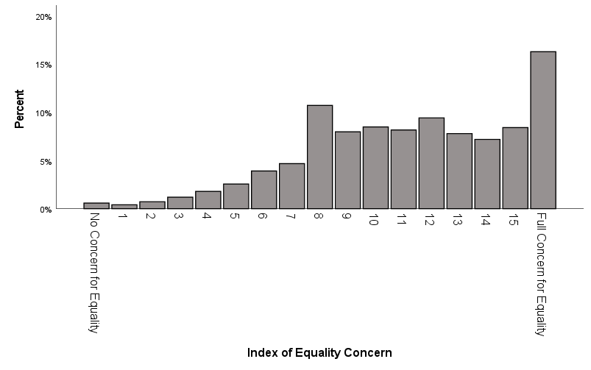

Index of Immigration Support
Eleven questions:
1.) Some people have proposed that the U.S. Constitution should be changed so that the children of unauthorized immigrants do not automatically get citizenship if they are born in this country. Do you favor, oppose, or neither favor nor oppose this proposal? Favor a great deal (coded as 0), Favor a moderate amount (coded as .17), Favor a little (coded as .33), Neither favor nor oppose (coded as .50), Oppose a little (coded as .67), Oppose a moderate amount (coded as .83), Oppose a great deal (coded as 1)
2.) Do you favor, oppose, or neither favor nor oppose separating the children of detained immigrants, rather than keeping them with their parents in adult detention centers?
Favor a great deal (coded as 0), Favor a moderate amount (coded as .17), Favor a little (coded as .33), Neither favor nor oppose (coded as .50), Oppose a little (coded as .67), Oppose a moderate amount (coded as .83), Oppose a great deal (coded as 1)
3.) Does illegal immigration increase, decrease, or have no effect on the crime rate in the U.S.?
Increase a lot (coded as 0), Increase a moderate amount (coded as .17), Increase a little (coded as .33), Have no effect (coded as .50), Decrease a little (coded as .67), Decrease a moderate amount (coded as .83), Decrease a lot (coded as 1)
4.) Now I’d like to ask you about immigration in recent years. How likely is it that recent immigration levels will take jobs away from people already here – extremely likely, very likely,
somewhat likely, or not at all likely? Extremely likely (coded as 0), Very likely (coded as .33), Somewhat likely (coded as .67), Not at all likely (coded as 1)
5.) Do you think the number of immigrants from foreign countries who are permitted to come to the United States to live should be increased a lot, increased a little, left the same as it is now, decreased a little, or decreased a lot? Decreased a lot (coded as 0), Decreased a little (coded as .25), Left the same as it is now (coded as .50), Increased a little (coded as .75), Increased a lot (coded as 1)
6.) Do you favor, oppose, or neither favor nor oppose providing a path to citizenship for unauthorized immigrants who obey the law, pay a fine, and pass security checks? Oppose a great deal (coded as 0), Oppose a moderate amount (coded as .17), Oppose a little (coded as .33), Neither favor nor oppose (coded as .50), Favor a little (coded as .67), Favor a moderate amount (coded as .83), Favor a great deal (coded as 1)
7.) Do you favor, oppose, or neither favor nor oppose allowing refugees who are fleeing war, persecution, or natural disasters in other countries to come to live in the U.S.? Oppose a great deal (coded as 0), Oppose a moderate amount (coded as .17), Oppose a little (coded as .33), Neither favor nor oppose (coded as .50), Favor a little (coded as .67), Favor a moderate amount (coded as .83), Favor a great deal (coded as 1)
8.) Do you favor, oppose, or neither favor nor oppose returning all unauthorized immigrants to their native countries? Favor a great deal (coded as 0), Favor a moderate amount (coded as .17), Favor a little (coded as .33), Neither favor nor oppose (coded as .50), Oppose a little (coded as .67), Oppose a moderate amount (coded as .83), Oppose a great deal (coded as 1)
9.) What should happen to immigrants who were brought to the U.S. illegally as children and have lived here for at least 10 years and graduated high school here? Should they be sent
back where they came from, or should they be allowed to live and work in the United States?
Favor a great deal they should be sent back (coded as 0), Favor a moderate amount they should be sent back (coded as .20), Favor a little they should be sent back (coded as .40), Favor a little they should be allowed to live and work in US (coded as .60), Favor a moderate amount they should be allowed to live and work in US (coded as .80), Favor a great deal they should be allowed to live and work in the US (coded as 1)
10.) Which comes closest to your view about what government policy should be toward unauthorized immigrants now living in the United States? Make all unauthorized immigrants felons and send them back to their home country (coded as 0), Have a guest worker program that allows unauthorized immigrants to remain in the US to work (coded as .33), Allow unauthorized immigrants to remain in US & eventually qualify for citizenship but only if they meet requirements (coded as .67), Allow unauthorized immigrants to remain in US & eventually qualify for citizenship without penalties (coded as 1)
11.) Do you favor, oppose, or neither favor nor oppose building a wall on the U.S. border with Mexico? Favor a great deal (coded as 0), Favor a moderate amount (coded as .17), Favor a little (coded as .33), Neither favor nor oppose (coded as .50), Oppose a little (coded as .67), Oppose a moderate amount (coded as .83), Oppose a great deal (coded as 1)

Combining these variables results in an index ranging from 0 = no support for immigration, up to 11 = full support for immigration

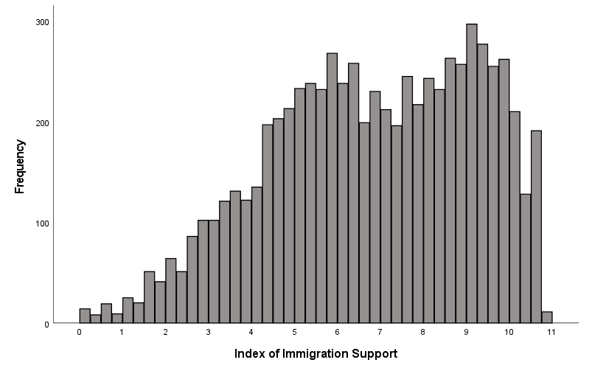

Index of Support for Gun Control
Three questions:
1.) Do you favor, oppose, or neither favor nor oppose banning the sale of semi-automatic “assault-style” rifles? Oppose a great deal (coded as 0), Oppose a moderate amount (coded as 1), Oppose a little (coded as 2), Neither favor nor oppose (coded as 3), Favor a little (coded as 4), Favor a moderate amount (coded as 5), Favor a great deal (coded as 6)
2.) Do you think the federal government should make it more difficult for people to buy a gun than it is now, make it easier for people to buy a gun, or keep these rules about the same as they
are now? Easier (coded as 0), Keep these rules about the same (coded as 3), More difficult (coded as 6)
3.) Do you favor, oppose, or neither favor nor oppose requiring background checks for gun purchases at gun shows or other private sales? Oppose a great deal (coded as 0), Oppose a moderate amount (coded as 1), Oppose a little (coded as 2), Neither favor nor oppose (coded as 3), Favor a little (coded as 4), Favor a moderate amount (coded as 5), Favor a great deal (coded as 6)

Combining these variables results in an index ranging from 0 = no support for gun control, up to 18 = full support for gun control.

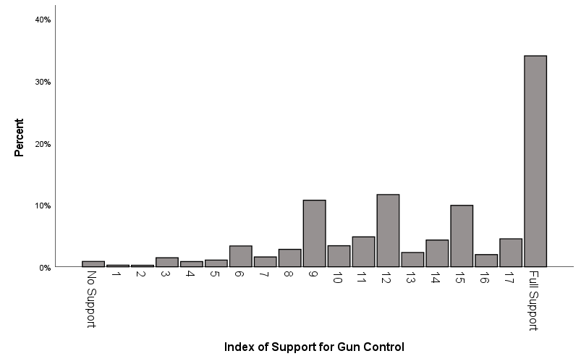

Index of Political Participation
Fourteen questions:
During the past 12 months, have you ever ____, or have you not done this in the past 12 months?
1.) gotten into a political argument with someone
2.) contacted a federal elected official, such as a member of Congress or the President, or
someone on the staff of such an official
3.) contacted a non-elected official in a federal government agency
4.) contacted an elected official on the state or local level, such as a governor, mayor, or a member of the state legislature or city council, or someone on the staff of such an elected official?
5.) contacted or tried to contact a member of the U.S. Senate or U.S. House of Representatives
6.) contacted a non-elected official in a state or local government agency
7.) given money to a religious organization
8.) given money to any other organization concerned with a political or social issue
9.) attend a meeting about an issue facing your local community or schools
10.) signed a petition on the Internet or on paper about a political or social issue
11.) posted a message or comment online about a political issue or campaign
12.) joined in a protest march, rally, or demonstration
13.) devote any time to volunteer work
14.) worked with other people to deal with some issue facing your community
Yes have done this in the past 12 months (coded as 1), No have not done this (coded as 0)

Combining these variables results in an index ranging from 0 = no activity, up to 14 = full activity.
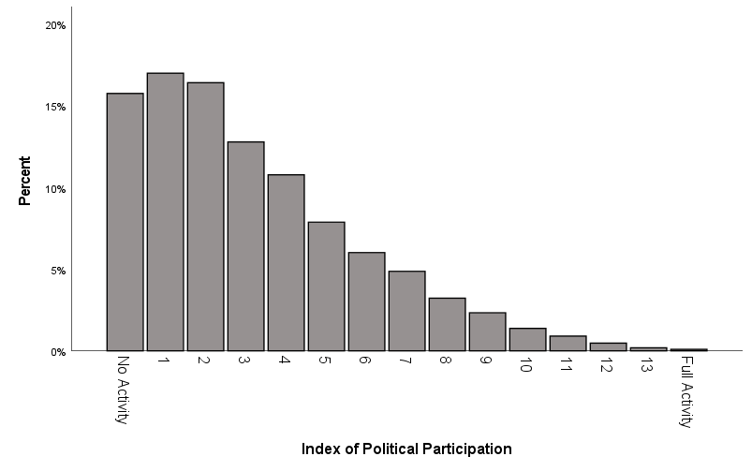

Index of Vaccine Support
Two questions:
1.) Do the health benefits of vaccinations generally outweigh the risks, do the risks outweigh the benefits, or is there no difference? Risks much greater than health benefits (coded as 0), Risks moderately greater than health benefits (coded as 1), Risks slightly greater than health benefits (coded as 2), No differences (coded as 3), Health benefits slightly greater than risks (coded as 4), Health benefits moderately greater than risks (coded as 5), Health benefits much greater than risks (coded as 6)
2.) Do you favor, oppose, or neither favor nor oppose requiring children to be vaccinated in order to attend public schools? Oppose a great deal (coded as 0), Oppose a moderate amount (coded as 1), Oppose a little (coded as 2), Neither favor nor oppose (coded as 3), Favor a little (coded as 4), Favor a moderate amount (coded as 5), Favor a great deal (coded as 6)

Combining these variables results in an index ranging from 0 = no support, up to 12 = full support.

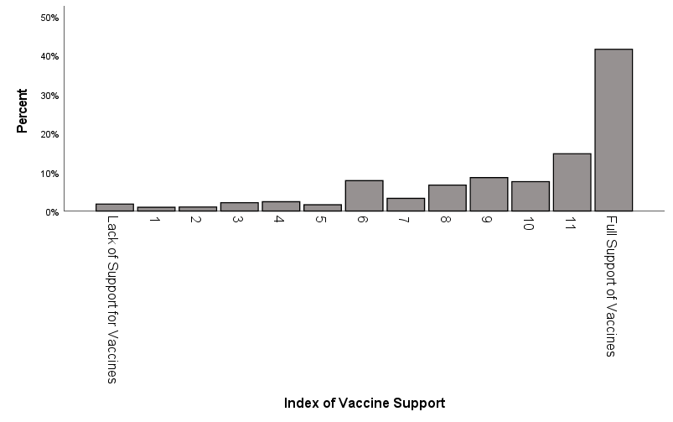

Index of Transgender Support
Two questions:
1.) Do you favor, oppose, or neither favor nor oppose allowing transgender people to serve in the United States Armed Forces? Oppose a great deal (coded as 0), Oppose a moderate amount (coded as 1), Oppose a little (coded as 2), Neither favor nor oppose (coded as 3), Favor a little (coded as 4), Favor a moderate amount (coded as 5), Favor a great deal (coded as 6)
2.) Should transgender people - that is, people who identify themselves as the sex or gender different from the one they were born as - have to use the bathrooms of the gender they were born, or should they be allowed to use the bathrooms of their identified gender? Feels very strongly transgender people should use the bathroom of birth gender (coded as 0), Feels moderately strongly transgender people should use the bathroom of birth gender (coded as 1), Feels a little strongly transgender people should use the bathroom of birth gender (coded as 2), Feels a little strongly transgender people be allowed to use the bathroom of identified gender (coded as 4), Feels moderately strongly transgender people be allowed to use the bathroom of identified gender (coded as 5), Feels very strongly transgender people be allowed to use the bathroom of identified gender (coded as 6)

Combining these variables results in an index ranging from 0 = no support, up to 12 = full support.

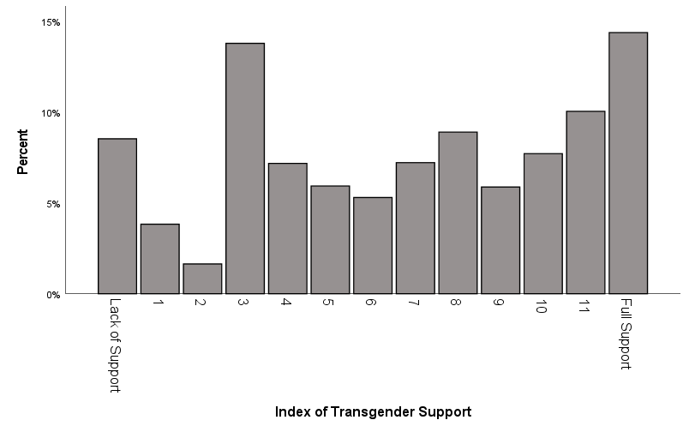

Index of Discrimination of Minority Groups
Seven questions:
For each of the following groups, how much discrimination is there in the United States today?
1.) Blacks
2.) Hispanics
3.) Asians
4.) Muslims
5.) Gays and lesbians
6.) Women
7.) Transgender people
None at all (coded as 0), A little (coded as 1), A moderate amount (coded as 2), A lot (coded as 3), A great deal (coded as 4)

Combining these variables results in an index ranging from 0 = lack of discrimination, up to 28 = full discrimination.

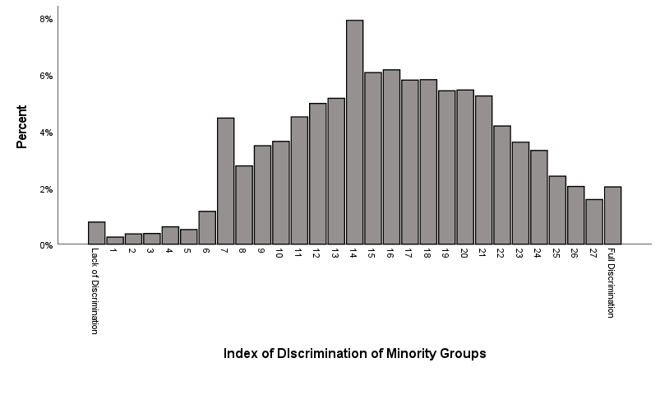
Index of Discrimination of Majority Groups
Three questions:
For each of the following groups, how much discrimination is there in the United States today?
1.) Men
2.) Whites
3.) Christians
None at all (coded as 0), A little (coded as 1), A moderate amount (coded as 2), A lot (coded as 3), A great deal (coded as 4)

Combining these variables results in an index ranging from 0 = lack of discrimination, up to 12 = full discrimination.

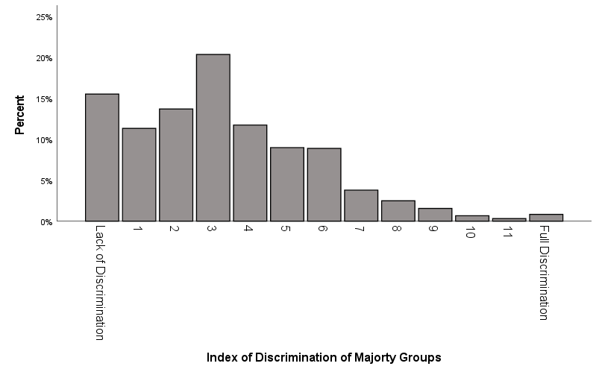

INTERACTION EFFECTS

XYINTSEXAGE: An interaction effect that multiplies XYSEX (the recoded sex variable) and the AGE variable

XYINTSEXATTEND: An interaction effect that multiples XYSEX (the recoded sex variable) and XYATTEND (the recoded religious attendance variable)

XYINTRACEWBAGE: An interaction effect that multiplies XYRACEWB (the dichotomous white/Black race variable) and the AGE variable

XYINTRACEPOLVIEWS: An interaction effect that multiplies XYRACEWB (the dichotomous white/Black race variable) and XYPOLVIEWS (the recoded POLVIEWS variable)

XYINTRACECLASS: An interaction effect that multiplies XYRACEWB (the dichotomous white/Black race variable) and XYCLASSDICH (the recoded dichotomous social class variable)

XYINTRACEFTCONS: An interaction effect that multiplies XYRACEWB (the dichotomous white/Black race variable) and the FTCONS variable (the Feeling Thermometer for conservatives)

XYINTRACESEX: An interaction effect that multiplies XYRACEWB (the dichotomous white/Black race variable) and XYSEX (the recoded sex variable)

SQUARED VARIABLES

XYAGESQ: the square of the age variable

XYATTENDSQ: the square of XYATTEND (the recoded religious attendance variable)

XYINCOMESQ: the square of XYINCOME (the recoded income variable)

XYPARTYIDSQ: the square of XYPARTYID (the recoded party identification variable)

UNIQUE GROUPS

In order to conduct analyses on a small number of cases, I located several unique groups within the ANES dataset by combining variables. Each of these were coded 1 if they were a member of this group and 0 if they were not a member of this group.
XYUNIQGLB22: Non-heterosexuals who are 22 years old.

XYUNIQSMASMN: Asian men who smoke

XYUNIQBITRLUV: Respondents who rate both Joe Biden and Donald Trump at 100 on the Feeling Thermometer

XYUNIQNOBLM: Black men who rate Black Lives Matter at 0 on the Feeling Thermometer

XYUNIQNAWARR: Native American women who have been arrested

XYUNIQNRICHSOC: Rich people who score socialists at 100 on the Feeling Thermometer

XYUNIQFEMNOME2: Feminists who score the #MeToo movement at 0 on the Feeling Thermometer

XYUNIQEDUCDIFF: the respondent has much less education than their spouse

