

Intl Journal of Public Administration

ISSN: 0190-0692 (Print) 1532-4265 (Online) Journal homepage: www.tandfonline.com/journals/lpad20

Support and Opposition for Invading Iraq: Did the President's Speech Make a Diﬀerence?

Juanita M. Firestone & Richard J. Harris

To cite this article: Juanita M. Firestone & Richard J. Harris (2006) Support and Opposition for Invading Iraq: Did the President's Speech Make a Diﬀerence?, Intl Journal of Public Administration, 29:10-11, 895-909, DOI: 10.1080/01900690600770629
To link to this article: https://doi.org/10.1080/01900690600770629

 Published online: 07 Feb 2007.

 Submit your article to this journal 

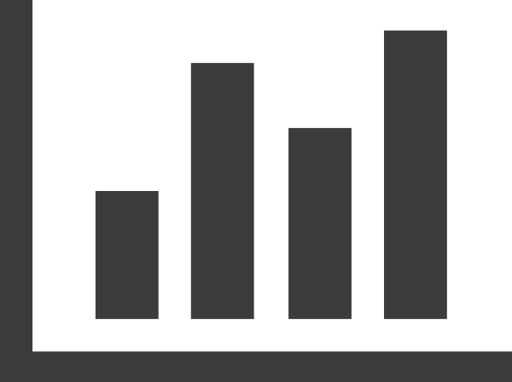 Article views: 167

 View related articles

 Citing articles: 1 View citing articles

Full Terms & Conditions of access and use can be found at https://www.tandfonline.com/action/journalInformation?journalCode=lpad20


Intl Journal of Public Administration, 29: 895–909, 2006 Copyright © Taylor & Francis Group, LLC
ISSN 0190-0692 print / 1532-4265 online DOI: 10.1080/01900690600770629

Support and Opposition for Invading Iraq: Did the President’s Speech Make a Difference?

Juanita M. Firestone and Richard J. Harris
Department of Sociology, The University of Texas at San Antonio, San Antonio, Texas, USA

Abstract: Utilizing data from the annual San Antonio Survey, this research addresses the issue of support and opposition to invading Iraq among respondents randomly selected from Bexar County, Texas. Data were collected prior to and after President Bush addressed the nation on October 7, 2002, seeking broad citizen support for his plan, allowing us to ascertain whether or not his speech impacted the attitudes of potential voters. Our results indicate that the President’s speech, along with the exten-sive media coverage about it, was effective in gaining support for his proposal to invade Iraq. A multivariate logistic regression analysis also displayed that the speech still had a significant impact even after controlling for confidence in the president, political orientation, race, ethnicity, nativity, and socio-demographic context. The find-ings suggest support for earlier research indicating that the impact of presidential speeches could boost the approval of a policy, in particular, if the speech occurred dur-ing his first term of office, was considered a “major” speech, was devoted to one important topic, and its primary focus was on foreign policy. Under these conditions, such a speech portrays the president as a strong leader.

Keywords: Iraq invasion, media impact, presidential speech, public opinion, survey research

In the post-9/11 period, President Bush actively sought support for the inva-sion of Iraq both within the United States and internationally. The strong Republican victory in the 2002 elections and the unanimous UN support for forcing Saddam Hussein to allow UN weapons inspectors into Iraq to insure that all weapons of mass destruction were destroyed were indications that Bush was quite successful. This research addresses the issue of support and opposition to invading Iraq among respondents randomly selected from Bexar

Address correspondence to Juanita M. Firestone, Department of Sociology, University of Texas at San Antonio, 6900 N, Loop 1604 W, San Antonio, TX 78249, USA; E-mail: jfirestone@utsa.edu

County, Texas. About 83% of the population in this county lives in the City of San Antonio. In addition, historically San Antonio has consisted of a large military community. Prior to the closing of several installations, Bexar County was home to five different military bases, and is still home to three. Thus, while we expect strong levels of support for the proposed invasion, we are interested in the impact on those initially claiming to be undecided. Data were collected prior to and after President Bush addressed the nation on October 7, 2002, seeking broad citizen support for his plan, allowing us to ascertain whether or not his speech impacted the attitudes of potential voters.

REVIEW OF THE LITERATURE

Early studies on the impact of media on society suggested the existence of a “hypodermic effect” such that the media injected information and opinions into people’s minds.^{[1]} However, subsequent empirical tests of this hypothesis indi-cated that any large change in public opinion based on media coverage was the exception rather than the rule.^{[2]} Later research suggested that the media do shape public opinion by setting specific public agendas^{[3]} and by selectively pre-senting topics in order to impact evaluations of over all presidential job perfor-mance.^{[4]} Thus when encountering an issue of importance in the media, a person is more likely to think it is an important issue for the general public than for him or herself.^{[5]} Furthermore, while, the media may not directly impact individual opinions, it may have indirect impacts by reinforcing existing beliefs.^{[6]}
Furthermore, evidence suggests that the trustworthiness of the source of the information impacts the extent that individuals are persuaded by what they hear or observe^{[7]} although this may be mediated by the amount and level of the indi-vidual’s political knowledge^{[8]} and by the individual’s education level.^{[9]} Miller and Krosnick^{[10]} found that trust in the media and knowledge of politics had the strongest impact on agenda setting by the media, although they found that agenda setting occurred among those who did not trust the media and those who were not knowledgeable about politics as well.
Any perusal of current media coverage makes clear that political parties and presidents use public speeches as a means to establish and persuade the public regarding policy agendas. Early literature related to the impact of pres-idential speeches on public opinion indicated that a speech could boost the president’s approval in particular if the speech occurred during his first term of office, was considered a “major” speech,^{[11]} or when the speech was devoted to one important topic.^{[12]} Cohen and Hamman^{[13]} further argue that only foreign policy speeches will have an important impact on presidential ratings because they portray the president as a strong leader.
Another thread of research examines the president’s ability to lead public opinion on specific policies, and finds that the popularity of the president impacts his ability to guide public opinion.^{[14]} Pfeffley, Langley, and Goidel^{[15]}

using data from a two-wave panel study of telephone respondents in Lexington Kentucky found that support for President Reagan’s air strikes against Libya in 1986 was impacted by a combination of an unusually strong presidential mes-sage, strong bipartisan support for his message and a barrage of favorable media coverage. In conclusion past research suggests that support for invading Iraq would increase following a strong presidential speech supporting this action.

DATA AND METHODS

The annual San Antonio Survey is a telephone survey of a stratified random sample of adults with telephones. In 2002, data were collected October 5–14. Questions are designed to measure San Antonians’ attitudes about and percep-tions regarding a variety of contemporary issues. Survey data were collected through UTSA’s Hispanic Research Center/Metropolitan Research and Policy Institute and the Survey Research Lab. The sample for this survey was com-prised of 457 adults with telephones living in the San Antonio SMSA. The standard error of the entire sample is +/− 4.6 percent with a 95 percent confi-dence level. Survey results were weighted by sex and race/ethnicity according to 2000 Census data for Bexar County.
Respondents were asked to respond to the following question with respect to invading Iraq:

President Bush has been attempting to build national and international support for a plan to invade Iraq. Please tell us how strongly you support or oppose the plan to invade Iraq. Response categories included; Strongly support; Support; Oppose; Strongly oppose; and Don’t Know.

DESCRIPTIVE RESULTS

As shown in Figure 1, in the complete sample (everyone who responded to the survey), slightly over one fourth of respondents strongly supported the plan and about three in ten supported the plan somewhat, producing a majority of 56% expressing at least some support for the invasion. Nineteen percent of respondents said they opposed the plan, 15% said they strongly opposed the plan while10% responded with “don’t know.”
On Monday evening, October 7, 2002 President Bush gave a televised speech regarding his proposal to invade Iraq. Prior to the President’s speech, political ana-lysts indicated that he sought broad citizen support for his plan, and that he hoped to influence those who “did not know” to understand the issue better. Figure 2 indicates the impact of the President’s speech on the overall results.^{[16]}
It seems very clear that he picked up support for the invasion, and that much of that support likely occurred from those who fell into the “don’t

don't know 10%

strongly oppose 15%
strongly support 25%

oppose 19%

Figure 1. Support/oppose invading Iraq.
support 31%

35.0%
32.3%
25.6%
25.4%
20.3%
17.9%
14.4%
7.4%
16.9%
16.5%
23.3%

30.0%

25.0%

20.0%

15.0%

10.0%

5.0%

0.0%
strongly support support oppose strongly oppose don't know
Before After
Figure 2. Support/oppose invading Iraq before and after President’s speech.

know” category. Note that the percentage of “don’t know” responses decreased about 9.4% after Bush’s speech and those supporting the invasion increased about 6.9% while those strongly supporting increased by 2.3%. Those strongly opposing the invasion decreased by 3.5%, while those oppos-ing the invasion increased by 3.8%. The changes in support/opposition, which occurred, are unlikely due to chance (p = .032) and moderate in strength (V =
.132). In the following figures, we examine the influence of the speech on var-ious demographic groups in San Antonio, in order to assess whether or not different constituencies were impacted differently. Because San Antonio is a “majority minority” city, ethnicity and geographic location as a reflection of ethnic segregation are particularly important factors.

In the complete sample, women were more likely to strongly oppose and oppose the invasion than were men in the sample (see Figure 3). In addition, women were almost twice as likely as men to say they “did not know” whether to support or oppose the proposed invasion (12.5% women; 6.2% men). Again, these differences are not likely due to chance (p = .05) and the relationship is moderate in strength (V = .144).
As shown in Figure 4, the President’s speech seems to have had a stron-ger impact on men in the Bexar County area. Before the speech, 21.5% of men

35.0%
32.6%
29.8%
29.8%
21.0%
20.6%
17.9%
16.1%
13.6%
12.5%
6.2%

30.0%

25.0%

20.0%

15.0%

10.0%

5.0%

0.0%
strongly support support oppose strongly oppose don't know
Men Women
Figure 3. Support/oppose invading Iraq by sex.

35.0%

30.0%

25.0%

20.0%

15.0%

10.0%

5.0%

0.0%

Men

Wom en M en Wom en

strongly support support oppose strongly oppose don' t know
Figure 4. Impact of President’s speech on men’s and women’s support/opposition to invading Iraq.

and 24.9% of women strongly supported the invasion, while 30.6% of men and 21% of women supported it. About 15% (14.9%) of men and 17.9 % of women opposed the plan, and 13.4% of men and 21.7% of women strongly opposed the proposal. Among women 14.6 % said they “did not know,” while 19.6% of men were in this category. Before the speech, differences between men and women are not statistically significant (p = .601) but are moderately strong (V = .158).
After the president’s speech, strong support among men increased to 32.2%, an increase of 10.7%, while strong support among women decreased 5.6% to 19.3% (See Figure 4). Support among men increased slightly to 33.1%, while support among women jumped over 10% to 31.6%. Note that the “don’t know” category for women dropped only slightly from 14.6% to 12.2%, while among men, “don’t know” responses dropped dramatically from 19.6% to 2.2%. Among both men and women those strongly opposed decreased slightly, and those opposed increased somewhat (see Figure 3). After the speech, the results are statistically significant (p = .001) and the dif-ferences between men and women are stronger (V = .228).
As depicted in Figure 5, African Americans/Blacks were most likely to oppose the invasion (40%) and to strongly oppose the invasion (25.6%) than were Whites (15.9%; 10.6%, respectively) and Hispanic/Mexican Americans (16.5%, 10.2%, respectively). Whites were more likely to support (36.4%) and strongly support (28.5%) than the other race/ethnic groups although the Hispanic/Mexican American percentages are very close to the white percent-ages for those who strongly supported the invasion (26.1%; 28.6% supported). Among Black/African Americans only 16.8% said they supported invading

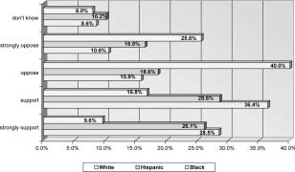
Figure 5. Support/oppose invading Iraq by race/ethnicity.

Iraq, while a mere 9.2% strongly supported the plan. Results were statistically significant (p = .006) and moderate in strength (V = .157).
Looking at results before and after the President’s speech (see Figures 6 and 7), we see important decreases in the “don’t know” responses for Whites (11,8% to 7.7%) and Hispanic /Mexican Americans (22.7% to 6.%).^{[17]}
In addition, strong support among Whites jumped from 20.1% to 30.6% and among Hispanic/Mexican Americans increased from 23.3% to 27.7%.

60.0%

50.0%

40.0%

30.0%

20.0%

10.0%

0.0%
White Hispanic Black
strongly support support oppose strongly oppose don't know
Figure 6. Support/oppose invading Iraq by race/ethnicity before President’s speech.

40.0%

35.0%

30.0%

25.0%

20.0%

15.0%

10.0%

5.0%

0.0%
White Hispanic Black
strongly support support oppose strongly oppose don't know
Figure 7. Support/oppose invading Iraq by race/ethnicity after President’s speech.

Support decreased slightly for Whites (38.0% to 35.6%) and jumped among Hispanic/Mexican Americans (17.6% to 31.1%.)
As shown in Figure 8, those aged 65 and older had the largest percentage in the “don’t know” category (15.2%) compared to 10.6% of those aged 18–29, 8.9% of those aged 49–64, and 5.8% of those aged 30–44. Those aged 30–44 were most likely to strongly support the invasion and those aged 18–29 were most likely to strongly oppose it. Age is only weakly related to this ques-tion (V = .099) and the relationship is not statistically significant (P = .361). The relationship remains non-significant when controlling for before and after the President’s speech (p = .737 and p = .182, respectively) but becomes a bit stronger (V = .162 and V = .128, respectively).
It is interesting to note that before the speech, the youngest aged group had the largest percentage in the “don’t know” category (24.4%) and this dropped dramatically to 7.7% after the speech (see Figures 8 and 9). The per-centage in the “don’t know” category increased slightly for the oldest age group (65 and older) from12.2% to 16.l6%.
Next we explored support for and opposition to the proposed invasion of Iraq by geographic quadrant of the city. Results indicated that those on the West side (both Southwest and Northwest) were most likely to fall into the “don’t know” category (see Figure 10). Those on the East side (both Southeast and Northeast) were most likely to “support” the invasion. Individuals living in the Southeast quadrant were most likely to “strongly support” the invasion (30.0%) followed closely by those living in the Southwest quadrant (27.2%). Those liv-ing in the Southwest and Northeast quadrants were most likely to strongly oppose the proposed invasion (18.0% each). However, the differences are not statistically significant (p = .610) and the relationship is weak (V = .09).

65+

45-64

30-44

18-29

0.0% 5.0% 10.0% 15.0% 20.0% 25.0% 30.0% 35.0%
strongly support support oppose strongly oppose don't know
Figure 8. Support/oppose invading Iraq by age group before President’s speech.

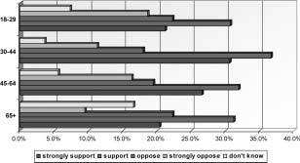
Figure 9. Support/oppose invading Iraq by age group after President’s speech.

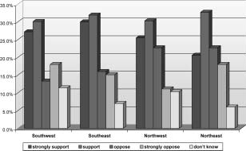
Figure 10. Support/oppose invading Iraq by geographic area.

Looking at the results before and after the Presidents speech (see Figures 11 and 12) shows a large decrease in the percentages saying “don’t know” among those living on the West side (both Northwest from 25.6% to 6.3% and Southwest from 10.4% to 7.8%). Support for the invasion increased substan-tially among those living on the Southeast from 12.2% to 34.1% after the speech, increased from 24.1% to 32% among those residing on the Northwest, and increased from 25.9% to 35.1% among those living on the Northeast.

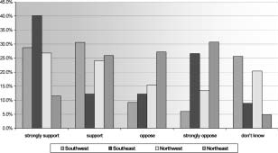
Figure 11. Support/oppose invading Iraq by geographic area before President’s speech.
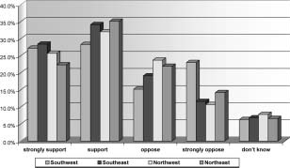
Figure 12. Support/oppose invading Iraq by geographic area after President’s speech.

Among those residing on the Southwest, opposition to the invasion increased after the speech (9.2% to 15.2% opposed; 6% to 23% strongly opposed). Nei-ther relationship (before (p = .130) or after the speech (p = .871)) is statisti-cally significant, although the relationship before the speech is much stronger (V = .245) than after the speech (V = .086).
Results from San Antonio are similar to those from national surveys in supporting the President’s proposal (see Table 1). Comparing the national

Table 1. Favor or Oppose Invading Iraq

2002 | %  Favor | %  Oppose | % No opinion
Nov 8–10 | 59 | 35 | 6
Oct 21–22 | 54 | 40 | 6
Oct 14–17 | 56 | 37 | 7
Oct 3–6 | 53 | 40 | 7
Source: CNN/USA Today/Gallup poll.

results (Table 1) during the period of time data were collected in Bexar County (Figure 1), we see that while respondents from San Antonio had a slightly higher percentage of people in the “don’t know” category, overall most approved the invasion plan. It is noteworthy that national support for the invasion increased between early October and early November. The final CNN/USA Today/Gallup poll results included in Table 1 indicated that nearly 6 in 10 Americans supported an invasion of Iraq to oust Saddam Hussein.
Finally, using the complete sample we explored the impact of confidence in the President on support or opposition to invading Iraq.
As seen in Table 2, clearly those individuals with a great deal of confi-dence were more likely to support the invasion of Iraq, while those with hardly any confidence were more likely to oppose the invasion. The relation-ship is statistically significant (p = .000) and strong (V = .430, gamma = .667).

MULTIVARIATE RESULTS

Table 3 presents the results of a logistic regression analysis designed to test whether the timing of the president’s speech and confidence in the president remain important predictors of response after controlling for other variables. It is noteworthy that both variables remain statistically significant even after

Table 2. Support/Opposition for Invading Iraq by Confidence in the President

Great Deal Confidence
Some Confidence
Hardly any Confidence

Strong Support | 43% | 18% | 5%
Support | 42% | 32% | 13%
Oppose | 12% | 33% | 25%
Strong Oppose | 3% | 17% | 58%
Total | 100% | 100% | 100%
N | 205 | 134 | 61
Chi sq = 147.615, df = 6, prob. = 000; Cramer’s V = .430; Gamma = .667

Table 3. Logistic Regression of Factors Predicting Support for Invading Iraq
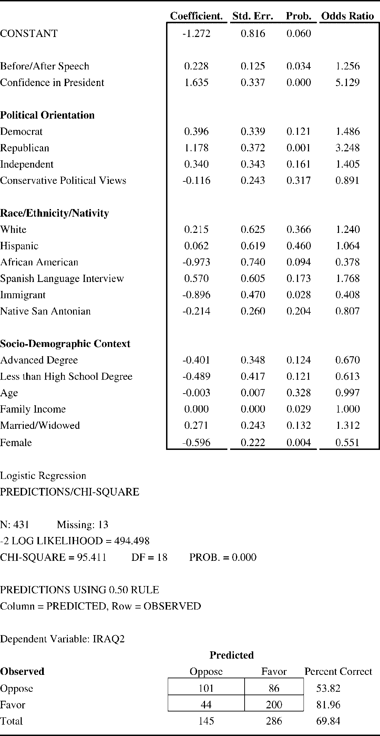

controlling for political orientation, race, ethnicity, nativity, and socio-demo-graphic context. Based on the Odds Ratio, it appears that confidence in the president overall had the stronger impact on support for the invasion, but it is striking that the speech retains sizable influence. Apparently this speech did indeed have an impact on shaping public response, at least in Bexar County and in the short term. This might reflect the power of a first term president giving an important and focused foreign policy speech.
Considering the independent effects of other variables, Republicans were more likely to support the invasion, immigrants were more likely to oppose the invasion, those with higher family incomes were more likely to support, and women were more likely to oppose the invasion. None of the other vari-ables were statistically significant. The classification results allow an assess-ment of the predictive power of this analysis. About 54% of those opposed were correctly predicted with these variables, while about 82% of those in favor were correctly predicted. The overall percent correctly predicted is about 70%.

CONCLUSION

Overall we would have to agree that the President’s speech, along with the extensive media coverage about it, was effective in gaining support for his proposal to invade Iraq. In most cases the percentages in the “don’t know” categories dropped dramatically with most of those moving into the “support” category. The multivariate logistic regression analysis also demonstrated that the speech still had a significant impact even after controlling for confidence in the president, political orientation, race, ethnicity, nativity and socio-demo-graphic context.
Finally, the findings suggest support for earlier research indicating that presidential speeches could boost the approval for a policy, in particular, if the speech occurred during his first term of office, was considered a “major” speech, was devoted to one important topic, and its primary focus was on for-eign policy. Under such conditions, viewers may believe the speech portrays the president as a strong leader. It seems clear that the power of President Bush’s message came through to respondents living in the San Antonio area. While people were supportive prior to the speech, the percentages supporting his proposal become stronger after the speech.
While our results support earlier research indicating that presidential speeches can be very persuasive in influencing public opinion, that support may be ephemeral. As recent events in Iraq indicate, unexpected, uncontrolla-ble events and crises may undermine even strong support very quickly. Thus, presidents may develop a false sense of power and influence from the ease with which they gain public support, but fail to note how quickly public opinion can shift, especially when the media present continuous, strong

commentary contrary to the president’s position. In the context of public administration, it is clear that leaders may well produce a dramatic short-term impact with effective, credible communication, but when it comes to main-taining long-term support, actions might speak louder than words.

REFERENCES
- Lasswell, H. D. Propaganda Techniques in the World War; Alfred A Knopf, Inc.: New York, 1927.
- Klapper, J. T. The Effects of Mass Communications; Free Press: Glencoe, IL, 1960.
- McCombs, M. E.; Shaw, D. L. The Agenda-Setting Function of the Mass Media. Public Opinion Quarterly 1972, 36, 176–187.
- Iyengar, S.; Kinder, D. R.; Peters, M. D.; Krosnick, J A. The Evening News and Presidential Evaluations. Journal of Personality and Social Psy-chology 1984, 46, 778–787.
- Eagly, A. H.; Chaiken, S. The Psychology of Attitudes; Harcourt Brace Jovanovich: Fort Worth, TX, 1993; McLeod, J. M.; Becker, L. B; Byrnes,
J. E. Another Look at the Agenda Setting Function of the Mass Media. Communication Research 1974, 1, 131–166.
- Mutz, D. C.; Soss, J. Reading Public Opinion: The Influence of News Coverage on Perceptions of Public Sentiment. Public Opinion Quarterly 1997, 6 (3), 431–451.
- Iyengar et al., 1984; Joslyn M. R.; Ceccoli, S. Attentiveness to Television News and Change in the Fall 1992 Presidential Campaign. Political Behavior 1996, 18 (2), 141–170.
- Krosnick, J. A.; Kinder, D. R. Altering the Foundations of Support for the President through Priming. American Political Science Review 1990, 84, 497–512.
- Iyengar, S. Television News and Issue Salience: A Reexamination of the Agenda-Setting Hypothesis. American Politics Quarterly 1979, 7, 395–416.
- Miller, J. M.; Krosnick, J. A. New Media Impact on the Ingredients of Presi-dential Evaluations: Politically Knowledgeable Citizens Are Guided by a Trusted Source. American Journal of Political Science 2000, 44 (2), 301–315.
- Ragsdale, L. The Politics of Presidential Speechmaking, 1949–1980. American Political Science Review 1984, 78, 971–984; Ragsdale, L. Res-idential Speechmaking and the Public Audience: Individual Presidents and Group Attitudes. Journal of Politics 1987, 49, 704–736; Brace, P.; Hinckley, B. Follow the Leader: Opinion Polls and the Modern Presi-dency; Basic Books: New York, 1992; Ostrom, C. W., Jr.; Simon, D. M. The Man in the Teflon Suit: The Environmental Connection, Political Drama, and Popular Support in the Reagan Presidency. Public Opinion Quarterly 1989, 53, 353–387.

- Cohen, J. E. Presidential Rhetoric and the Public Agenda. American Journal of Political Science 1995, 9 (1), 87–107; Cohen, J. E.; Hamman,
J. A. The Polls: Can Presidential Rhetoric Affect the Public’s Economic Perceptions? Presidential Studies Quarterly 2003, 33 (2), 408–422.
- Cohen and Hamman, 2003.
- Edwards, G. C., III. The Public Presidency: The Pursuit of Popular Sup-port; St. Martin’s Press: New York, 1983; Kernell, S. Going Public: New Strategies of Presidential Leadership, 1st Ed; CQ Press: Washington DC, 1993; Mondak, J. Source Cues and Policy Approval: The Cognitive Dynamics of Public Support for the Reagan Agenda. American Journal of Political Science 1993, 37, 186–212; Page, B. I.; Shapiro, R. Y. The Rational Public: Fifty Years of Trends in Americans’ Policy Preferences; University of Chicago Press: Chicago, 1992; Rosen, C. M. A Test of Presidential Leadership of Public Opinion: The Split-Ballot Technique. Polity 1973, 6, 282–290; Sigelman L; Sigelman, C. K. Presidential Lead-ership of Public Opinion: From “Benevolent Leader” to “Kiss of death?” Experimental Study of Politics 1981, 7, 1–22; Thomas, Dan; Sigelman, Lee. Presidential Identification and Policy Leadership: Experimental Evi-dence on the Reagan Case. In Edwards, George C.; Shull, Steven A.; Thomas; Norman C. Eds. The Presidency and Public Policy Making; University of Pittsburgh Press: Pittsburgh, PA, 1985.
- Peffley, M.; Langley, R. E.; Goidel, R. K. Public Responses to the Presi-dential Use of Military Force: A Panel Analysis. Political Behavior 1995, 17 (3), 307–337.
- Unless noted as “Before Speech” or “After Speech” data include com-plete sample results. Results labeled “Before Speech” include only those surveyed before the speech or during the evening he was speaking. Results labeled “After Speech” include only those surveyed on days after the speech.
- Results for African Americans/Blacks are illustrative, but should be treated with caution because few cases were part of the sample collected before the President’s speech (6 cases). Differences are statistically sig-nificant in both cases (p = 024; p = .006) and strong to moderate (.288 to
.185), but comparisons before the speech should be treated with caution.

